CCR 700-1
ROTC Standardized Logistics Policy and Procedures

Original Document Date: 03/01/00

Revision Date: 06/02/03

Summary:
This regulation on standardized logistical management in U.S. Army Cadet Command (CC) has been revised. It prescribes policy and procedures for management of property books and accounting records, weapons accountability and management, informal accountability of property, bonding and insurance requirements, Army purchase card (I.M.P.A.C.®) management, providing General Services Administration (GSA) fleet information, and conducting other logistical management tasks (e.g., coordinating with the supporting installations, developing support agreements, obtaining transportation support, etc.).
POC/Impact:
Applicability. This regulation applies to all Cadet Command staff agencies, ROTC regions, ROTC brigades, and ROTC battalions, i.e., Senior ROTC (SROTC)/Junior ROTC (JROTC) and Contractor Personnel.
Supplementation. Supplementation of this regulation is prohibited without approval from Commander, U.S. Army Cadet Command (ATCC-RM), Fort Monroe, VA 23651-5000.
Forms. "R" Forms at the back of this regulation are for local reproduction. Have them printed through the Forms Management Officer..
Suggested Improvements. Send comments and suggested improvements to Commander, U.S. Army Cadet Command (ATCC-RM), Fort Monroe, VA 23651-5000, using DA Form 2028 (Recommended Changes to Publications and Blank Forms).

Details:
Table Of Contents

Chapter 1, Introduction
1-1 | Purpose
1-2 | References
1-3 | Explanation of Abbreviations and Terms
1-4 | Responsibilities
1-5 | Installation Support

Chapter 2, Accounting For and Controlling Property
2-1 | General
2-2 | Assigning Property Responsibility
2-3 | Property Authorization Documents
2-4 | Property Accountability
2-5 | Requesting and Receiving Supplies
2-6 | Asset Reporting
2-7 | Storage of Supplies
2-8 | Evaluations, Inspections, and Inventories
2-9 | Disposition of Supplies and Equipment (other than clothing)
2-10 | Cadet Clothing
2-11 | Commutation of Uniforms
2-12 | Authorized Sales and Purchases of Military Clothing
2-13 | Organizational Clothing and Individual Equipment (OCIE)
2-14 | Ammunition
2-15 | Operational Rations
2-16 | Accounting for Lost, Damaged, and Destroyed Property

Chapter 3, Weapons
3-1 | Control of Weapons
3-2 | Weapons Management

Chapter 4, Miscellaneous Logistical Requirements
4-1 | General
4-2 | Bonding/Insurance
4-3 | GSA Customer Supply Center Account
4-4 | Fuels (Diesel/Motor Gasoline)
4-5 | Supply Training
4-6 | Interservice Support Agreement (ISA)
4-7 | Heraldic Items
4-8 | Logistics Filing System

Chapter 5, I.M.P.A.C.® Government Services Card Procedures
5-1 | General
5-2 | Responsibilities
5-3 | Unauthorized Purchases and Supply Sources
5-4 | Purchase Restrictions
5-5 | Misuse of the I.M.P.A.C.® Card
5-6 | Semi-Annual Audit Procedures

Chapter 6, General Services Administration (GSA) Vehicle Fleet Management
6-1 | General
6-2 | Vehicle Authorizations
6-3 | Vehicle Asset Allocations
6-4 | Acquisition of GSA Vehicles
6-5 | Accountability and Disposition of Assigned GSA Vehicles
6-6 | U.S. Government Fleet Services Card Management
6-7 | Vehicle Dispatch Procedures
6-8 | Standard Utilization Levels for Assignment of GSA Vehicles
6-9 | Mileage Allocation and Permissible Operating Distance (POD)
6-10 | Authorized use of Government Vehicles
6-11 | Vehicle Use Limitations, Restrictions, Penalties, Priority of Services, Rules of Operation, and Official Use Determinations
6-12 | Unauthorized Uses of Government Owned Vehicles
6-13 | Domicile to Duty
6-14 | Requirements for Vehicle Operator’s License
Chapter 6, General Services Administration (GSA) Vehicle Fleet Management (continued)
6-15 | Personnel Authorized to Drive GSA Vehicles
6-16 | Compliance with Traffic Laws
6-17 | Federal Driver Government Insurance
6-18 | Vehicle Maintenance and Care Responsibilities
6-19 | Grounds for Vehicle Withdrawal
6-20 | Motor Vehicle Safety Program
6-21 | Hazardous Materials Transportation (HAZMAT)
6-22 | Vehicle Accident Reporting
6-23 | Investigating Vehicle Accidents
6-24 | Accounting for Vehicle Damages
6-25 | Charges for GSA Vehicle Damage
6-26 | GSA Vehicle Modifications and Special Accessory Equipment
6-27 | Identifying and Marking GSA Vehicles
6-28 | Alternative Fuel Vehicle (AFV) Program
6-29 | Vehicle Cost Accounting and Management Reporting
6-30 | Reporting Requirements and Forms
6-31 | Leaders Training Course/National Advanced Leadership Camp Vehicle Support

Appendices
 | Section I, Abbreviations
A | Reference Publications
B | Reference Forms

Chapter 1, Introduction

1-1. Purpose. This regulation provides the policy and procedures for logistical management within U.S. Army Cadet Command. It provides instructions for accountability and assignment of property responsibility, I.M.P.A.C.® purchase card procedures, GSA vehicle fleet management, requesting and receiving supplies and equipment, weapons management and other miscellaneous logistical management functions.
1-2. References. Required and related publications are listed in Appendix A and the FAQ for Logistics.
1-3. Explanation of Abbreviations and Terms
Please refer to Section I (also referenced in the Cadet Command Right Site Glossary).
1-4. Responsibilities
a. The Commanding General, Cadet Command (CGCC), exercises supervision and effective management of logistical operations by--
(1) Ensuring the development, distribution, and implementation of logistical policy and procedures command wide.
(2) Providing logistical assistance to each region and brigade headquarters as well as each battalion (SROTC/JROTC).
(3) Appointing a Command Supply Discipline Program (CSDP) Coordinator (see sample memorandum at Figure 1-1).

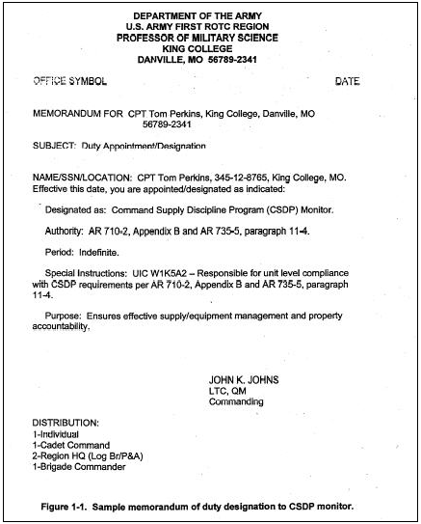
Figure 1-1
(4) Enforcing the command's CSDP requirements in accordance with (IAW) AR 710-2, Appendix B.
(5) Overseeing management of GSA vehicles IAW Chapter 6 of this regulation.
(6) Appointing a Cadet Command Fleet Manager (CCFM) who develops and implements GSA Fleet management policy and procedures. Specific responsibilities of the CCFM are listed under GSA Fleet Management.
(7) Maintaining liaison with counterparts at higher and lateral commands to ensure interchange of information on fleet management policy application and operational experience.
(8) Ensuring compliance with the management control program and internal audit program.
(9) Conducting field visits and providing technical assistance to field units.
b. ROTC Region Commanders.
(1) The ROTC region commander has appeal authority on Reports of Survey (ROS), DA Form 4697 (Department of the Army Report of Survey) per AR 735-5, paragraph 13-49. The region commander designates approving and appointing authority per AR 735-5, Paragraph 13-16. This authority shall not be delegated below Brigade Commander. The brigade/camp commanders will not act as the appointing or approving authority where personal responsibility for the property exists at the time the property became lost, damaged or destroyed. In such cases, the region commander will act as the appointing and approving authority; and in this instance, the CGCC has appeal authority.
(2) Also, the region commander appoints a property book officer (PBO) or designates a primary hand receipt holder (PHRH), as applicable, to be responsible for the region headquarter's property (DA PAM 710-2-1, Paragraph 5-3). The Chief, Resource Management Division, supervises the overall region’s supply operation and will--
(a) Provide logistical advice and assistance to assigned region staff, training activities, and camp operations.
(b) Maintain visibility over all region’s property losses, ensure timely processing of ROS, Statement of Charges (SC)/Cash Collection Vouchers (CCV), DD Form 362, and monitor the dollar value of losses.
(c) Certify the conduct of management control reviews IAW AR 11-2.
(d) Inspect each brigade's logistics operation (SROTC and JROTC) using the appropriate checklist in CCR 145-8.
(e) Designate a Region Fleet Manager (RFM) who will be responsible for the Region Headquarters' GSA vehicle fleet management requirements. Also, the RFM will support the Leader's Training Course (LTC)/National Advanced Leadership Camp (NALC) vehicle requirements (see specific responsibilities published under GSA Fleet Management).
c. Brigade commander. The brigade commander ensures compliance with this regulation and other logistical directives by--
(1) Designating a logistics representative to supervise overall brigade logistics management.
(2) Appointing a PBO or designating a PHRH, as applicable, to be responsible for the brigade headquarter's property (DA PAM 710-2-1, Paragraph 5-3). (See sample memorandums at Figures 1-2 and 1-4.)
(3) Appointing a CSDP coordinator IAW AR 710-2, Appendix B (see sample memorandum at Figure 1-1).
(4) Ensuring effective supply management and property accountability for all battalions and Goldminer Teams under their command.
(5) Certifying the conduct of management control reviews IAW AR 11-2.
(6) Ensuring corrective actions on deficiencies by battalions in a timely manner.
(7) Establishing annual logistical visit schedules to battalions and coordinate schedules with the region and with Cadet Command.
(8) Acting as liaison between the ROTC battalions and the support installations on solving problems.
(9) Overseeing brigade property loss management program (i.e., including timely and accurate processing of ROS, SC, and CCV).
(10) Monitoring the brigade excess program and approve/disapprove lateral transfers (L/T) of property.
(11) Reviewing battalion's equipment requirements for both table of distribution and allowances (TDA) and common table of allowance (CTA) items; and ensuring all new requests (DA Forms 2028 and 4610-R) are properly prepared, fully justified, and forwarded to HQCC for approval.
(12) Designating a brigade fleet manager (BFM) to oversee and manage GSA vehicle fleet management operation as well as all other transportation requirements per Chapter 6 of this regulation. The BFM specific responsibilities are published under GSA Fleet Management.
d. SROTC battalion commanders and Heads of Educational Institutions (HOEI). Property responsibility and accountability in a SROTC battalion may occur in one of three ways. First, the HOEI hosting a SROTC program may elect (per AR 710-2, Paragraph 2-24) to account for the government property issued for ROTC use. In this situation, the HOEI appoints a Military Property Custodian (MPC) to be responsible and accountable for government property; and to manage it IAW Army policy and procedures (see provisions of Paragraph 4-2 below, this regulation, regarding bonding and insurance). Secondly, the HOEI hosting a SROTC program may request the Army to account for and manage the government property for the SROTC per AR 710-2, Paragraph 2-24. In this instance, the battalion commander assumes the responsibility and accountability for the government property. Thirdly, the Government property may be managed by a contractor. In this regard, the provisions of the contract and AR 735-5, Paragraph 2-5 applies. The SROTC battalion commanders and HOEI will--
(1) Implement and comply with this regulation and other logistical directives.
( 2) When under manual property book operations, ensure the appointment of a PBO or MPC, to account for and manage all of the battalion's property (see sample memorandums at Figure 1-2 and Figure 1-3 below). When supported by a consolidated installation property book officer (CIPBO), designate a PHRH IAW DA Pamphlet 710-2-1, Paragraph 5-3 and the CIPBO's instruction. Also, ensure the appointment of a representative to supervise the battalion logistics management.

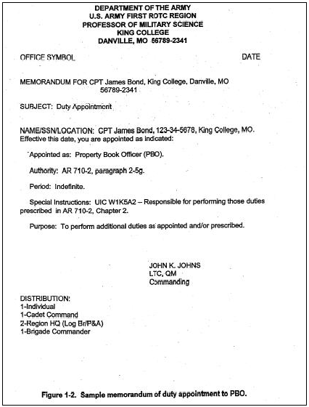
Figure 1-2
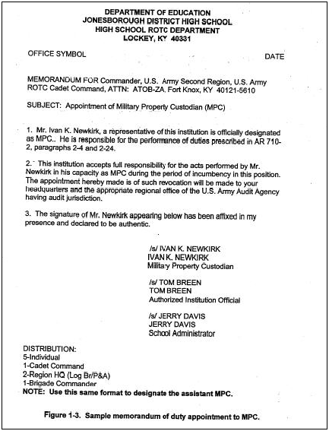
Figure 1-3

(3) Ensure strict security for military property in use and in storage per AR 190-51.
(4) Designate a CSDP monitor other than PBO/MPC/PHRH, to ensure compliance with the provisions of AR 710-2, Appendix B, (see sample at Figure 1-4 below).

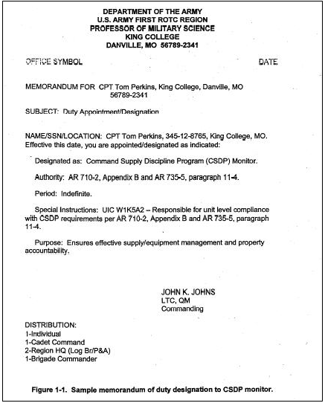
Figure 1-4

(5) Evaluate logistical management in the battalion periodically using the logistics checklist in CCR 145-8-2 (SROTC) or CCR 145-8-3 (JROTC).
(6) Designate a Unit Vehicle Control Coordinator (UVCC) who will be responsible for the battalion GSA vehicle management (see specific responsibilities published under GSA Fleet Management). The UVCC will oversee duties of the vehicle operator.
(7) Establish and implement standing operating procedures (SOP) for management of the logistics operations. Ensure the SOP contains, at a minimum, procedures for--
(a) Requesting, receiving, issuing and turning-in supplies.
(b) Handling funds collected from cadets.
(c) Security of government property and key control.
(d) GSA vehicle management.
(e) Unit vehicle Operator's responsibilities (reference GSA Fleet Management).
(f) Support installation points of contact.
(g) I.M.P.A.C.® credit card management controls.
e. JROTC. The HOEI hosting the JROTC program is responsible and accountable for the government property issued for use per AR 710-2, Paragraph 2-24. They assume responsibility and ensure completion of the same tasks cited for SROTC battalion commanders (see paragraph 1-4d above). The HOEI appoints an MPC (see sample memorandum at Figure 1-3) to perform logistics tasks, to be responsible and accountable for government property, and to manage it IAW Army policy and procedures (see provisions in Paragraph 4-2 below regarding bonding and insurance). The MPC is responsible for informing institution authorities in writing of all facts, circumstances, and conditions that appear prejudicial to the proper protection of government property against loss, damage, or destruction. If no action is taken by institution officials, the MPC will notify the appropriate officials at brigade headquarters. The MPC will perform the function of the PHRH when required.
1-5. Installation Support. Installation support responsibilities are prescribed in AR 5-9.

Chapter 2, Accounting For and Controlling Property

2-1. General. This chapter provides basic policy for controlling and accounting for government property in ROTC units/activities (agencies) through formal and informal means.
a. Formal accountability for property will be through either consolidated installation property book (under automated procedures at the support installation), or by manual property book procedures maintained at the ROTC agency level.
b. Informal accounting procedures will be established at each ROTC agency (where applicable) to account for items approved under TRADOC waivers WA-0385 (Property $2500 or less), WA-0393 (CTA 50-900, Table 4 Items), and AR 710-2, Paragraph 2-5, for ROTC RPA funded clothing (formerly waiver WA-0357 (Cadet Clothing).
2-2. Assigning Property Responsibilities. Commanders and HOEI will ensure appointment/ designation of an individual to be responsible for the agency's property under both manual and consolidated procedures (Paragraphs 1d(2) and 1e above). When the property book is established at the ROTC agency's level, ensure the appropriate property responsibility/ accountability statements are prepared and executed per the sample DA Form 3328 at Figure 2-1 below, Parts A, B, and C. Consult detailed procedures when assigning property responsibility for both manual property book and CIPBO procedures.

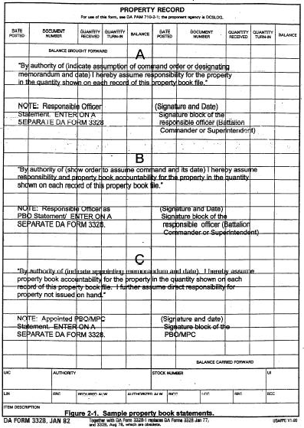
Figure 2-1

2-3. Property Authorization Documents. This paragraph prescribes policy for equipment authorizations other than weapons and vehicles. For weapon authorizations, see Chapter 3 and for vehicle authorizations, see Chapter 6.
a. The commander/HOEI will ensure that the unit acquires, accounts for, and controls property on the basis of allowances. Cadet Command will establish a consolidated basis of issue document which ROTC agencies may use for developing unit requirements. HQDA source documents applicable to equipment authorizations in ROTC units follow:
(1) Organizational equipment--table of distribution and allowances (TDA).

(2) Personal clothing and equipment--common table of allowances (CTA) 50-900), Tables 1 and 2.
(3) Organizational clothing and individual equipment (OCIE)--CTA 50-900, Table 4.
(4) Office equipment and furnishings--CTA 50-909.
(5) Expendable supplies--CTA 50-970.
(6) Operational rations-- AR 30-1 (see Paragraph 2-15, this regulation).
(7) Commercial nonstandard items costing $100,000 and less-- AR 71-32.
(8) Flags and guidons--reference AR 840-10.
b. Authorized levels. The supply representative will comply with basic provisions of AR 710-2, Paragraphs 2-4 and 2-26, and the following guidance:
(1) Use the roster of enrolled cadets to justify quantities of cadet clothing (CTA 50-900, Tables 1 and 2) items on hand and on request. In JROTC units, ensure that computation of allowances conforms to the uniform option selected (i.e., Class A or Class B uniforms). See JROTC uniform options.
(2) Compute authorized OCIE quantities IAW the established basis of issue (BOI) per CTA 50-900, Table 4, or the single source document. Use discretion in computing authorizations and acquire only the minimum quantity of items essential for mission accomplishments.
(3) Fully justify all requests for commercial nonstandard items (per the justification criteria per Table 2-1 below) and forward them to the brigade/region for approval prior to purchase. The brigade will assign an internal control number for each approved request and maintain a file for all approved requests IAW AR 25-400-2.
(4) Annually, reconcile allowances on the ROTC agency’s property book with authorization documents (AR 710-2, Paragraph 2-4b). The commander and HOEI acknowledge in writing, the completion of the annual reconciliation and maintain a copy of the statement on file at the ROTC agency.
c. TDA and CTA change requests. ROTC agencies initiate changes by submitting a DA Form 2028 or DA Form 4610-R (Equipment Changes in MTOE/TDA). Prepare a separate DA Form 4610-R and justification for each line item number (LIN) (see sample at Figures 2-2a/2-2b below). DA controlled equipment is approved by the U.S. Army Training and Doctrine Command (TRADOC) and the U.S. Force Management Agency; therefore, fully justify all requirements per Table 2-1 below. The responsible ROTC agency initiates and processes all change requests. Forward all additions and increases to equipment authorizations through brigade headquarters to Cadet Command for approval action. When requesting changes to the CTA and TDA, comply with AR 71-32.

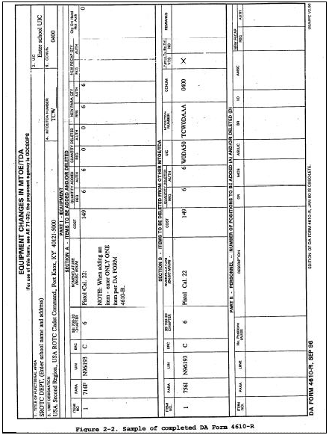
Figure 2-2a

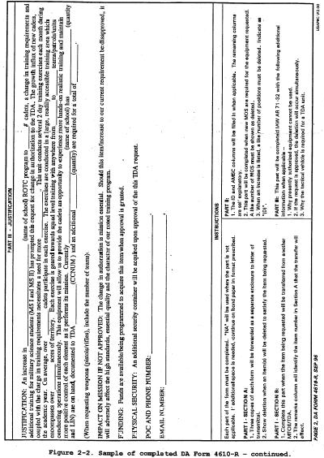Figure 2-2b

Table 2-1
Criteria for Justification
Justify all requests for additions and increases to TDA equipment requirements. As a minimum, justify requests as follows:
a. | Requirements Justification. It is imperative to provide complete and meaningful justification on all TDA change requests. Explain exactly why the additional item(s) or increase is required and how the mission previously managed without the requested item. Identify such information as type and number of teams (also the number of team members), enrollments, training requirements, personnel composition, how often equipment will be used, etc. Clearly state the requirement as it relates to the program of instruction (POI) or mission.
 | (1) Although the equipment requested may be within the BOI, it does not necessarily mean automatic granting approval authority for documenting it on the TDA.
 | (2) Having the equipment on-hand and indicating no additional cost does not automatically justify its retention and/or approval. Turn-in the equipment if it cannot be fully justified.
b. | Physical Security (weapons/sensitive items). Address the adequacy of the current existing physical security or the requirements for additional weapons and/or new physical security.
c. | Funding. Indicate cost of equipment requested and the availability of funds or whether it is unfinanced.
d. | Impact on the unit if not approved.
 | (1) Clearly state the impact on mission if the request is disapproved.
 | (2) Indicate the alternative sources for obtaining the requested equipment; e.g., loan from depots, reserve components, supporting installations, etc.
e. | Mandatory Statement required. Enter on transmittal memorandum the mandatory statement.
Table 2-1

2-4. Property Accountability
Account for ROTC property as follows:
a. Consolidated property book procedures. The CIPBO accounts for ROTC property under automated procedures. The type of ROTC property accounted for on automated property books is TDA items (see Chapter 6 for vehicle accounting), flags and guidons, commercial items over $2,500, computers and computer accessories, Information Management Processing Equipment (IMPE), see per DA Pamphlet 710-2-1, Para 4-39, weapons (to include demilitarized dummy rifles), reportable items, sensitive items, and pilferable items (per DA Pamphlet 710-2-1, Paragraph 4-4a(2)). ROTC PHRH will follow guidelines provided by the CIPBO. Headquarters Cadet Command (HQCC) and brigade logistics representatives will provide CIPBO the current documents and changes relative to Cadet Command policy, equipment authorizations, etc.
b. ROTC manual property book procedures. Where the property book function is not done by the support installation, the ROTC agency shall maintain a manual property book to account for the type property listed in Paragraph 2-4a, above (see Chapter 6 for vehicle accounting). The ROTC agency supply representative complies with DA procedures.
c. Informal accounting procedures. ROTC battalions (SROTC/JROTC) account for the type property listed at Paragraph 2-1b above using informal accounting procedures per AR 710-2, Paragraph 2-5. For cadet clothing (Reserve Personnel, Army (RPA) funded) and OCIE (Operation Maintenance, Army (OMA) funded), see Paragraphs 2-10 and 2-13 below. Account for all other property exempted for accountability (facsimile machines, visual aid equipment, furniture, etc.), per DA Pamphlet 710-2-1, Paragraph 5-7, Figure 5-6.
2-5. Requesting and Receiving Equipment and Supplies
a. Acquiring supplies and equipment by ROTC agencies may be accomplished by forwarding an appropriate request to the CIPBO or the support installation (SI) accountable officer. The CIPBO and SI accountable officer will usually prescribe the methods and procedures to be used (see Chapter 3 for weapons and Chapter 6 for vehicles). In many instances, ROTC agencies may be instructed to use the government credit card. When using the government credit card, follow the instructions at Chapter 5 of this regulation.
b. Requesting supplies and equipment from the CIPBO and SI accountable officer requires ROTC agency’s adherence to policy and procedures in AR 710-2, Paragraphs 2-6 and 2-8; and DA Pamphlet 710-2-1, Paragraphs 2-1 and 2-2.
c. Requests for property from Defense Reutilization and Marketing Office (DRMO). The PBO/MPC will process all requests through the supply support activity (SSA). Battalion commanders will not request supplies directly from the DRMO. The brigade commander will approve all requests for items regardless of the intended purpose. Account for all non-expendable property drawn through the SSA from DRMO on the battalion’s property book.
d. Document Register for Supply Actions (DA Form 2064). The document register is a record of document numbers assigned to supply transaction documents. It serves as the suspense file for open supply request transactions. ROTC agencies supported by a consolidated property book will be required to maintain an expendable/durable document register when instructed by the CIPBO. In this instance, units and activities will follow instructions of the CIPBO for document register management. When the CIPBO does not issue the required block of document numbers, the ROTC unit (senior and junior) will establish and maintain an expendable/durable document register to record all supply transactions pertaining to informal clothing and OCIE management. Agencies with their own property book will maintain active and inactive document registers for both non-expendable and expendable/durable transactions. When the CIPBO does not issue the required block of document numbers, the ROTC unit (senior and junior) will establish and maintain an expendable/durable document register to record all supply transactions pertaining to informal clothing and OCIE management. Agencies with their own property book will maintain active and inactive document registers for both non-expendable and expendable/durable transactions. The PBO and MPC will identify and publish in a memorandum document serial numbers to be assigned to supply transactions (see Figure 2-3A below). File a copy of the memorandum in front of each register. (See sample at Figure 2-3B below.)

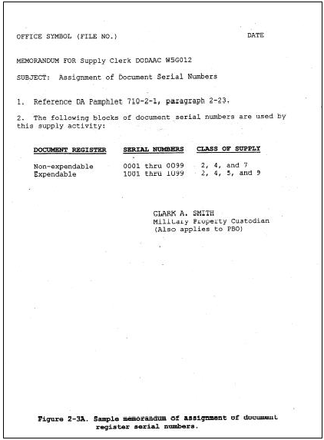
Figure 2-3A

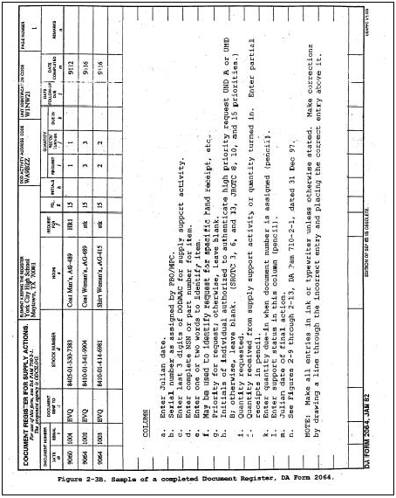
Figure 2-3B

e. Supporting document file. This file contains all documents that support closed-out entries on the non-expendable document register (DA Pamphlet 710-2-1, Paragraph 4-16), and expendable/durable document register applicable to disposal at the unit of cadet clothing and OCIE. Consult the instructions.
2-6. Asset Reporting. This paragraph is only applicable to units with manual property books. Asset reporting in ROTC Cadet Command units requires special actions by the PBO/MPC. It involves the accounting and reporting processes for major items and major secondary items (those listed with Reportable Item Control Codes (RICC) 2 and A in SB AR 700-20), and small arms (defined in AR 710-3, Chapter 4)). The ROTC PBO/MPC will report assets through both procedures the Continuing Balance System-Expanded (CBS-X) and the Unique Item Tracking (UIT). Also, they will conduct the required annual reconciliation as directed by HQDA.
2-7. Storage of Supplies
a. General. Supply representatives will use the following guidance to ensure proper storage of equipment and supplies:
(1) Use labels (tags for items stored on pallets) to reflect the identity of items; e.g., nomenclature, national stock number (NSN), quantity, etc.
(2) Separate government property from school property and that property donated or purchased by the institution and cadet fund raisings.
(3) Ensure security of all government property IAW AR 190-51.
(4) Use storage equipment for clothing that is insect treated, clean, and has smooth surfaces.
b. Operational rations. Applicable to SROTC unit only.
(1) Operational rations require only temporary storage since they are normally consumed within the same school year.
(2) Store rations in an area with limited access to safeguard them from theft.
(3) Ensure protection from rodents through use of bait, traps, or other approved methods.
(4) Store rations in a clean, dry area on dunnage at least 2 inches off the floor and 24 inches away from walls.
(5) Store identical lot numbers together with identification data (lot number and date of pack) facing toward the aisles.
2-8. Evaluations, Inspections, and Inventories
a. General. Each ROTC command level logistics operation requires evaluation annually (biennially or triennially if funds are not available). When conducting inspections, comply with evaluation and inventory requirements per AR 710-2, Paragraph 2-12 and Table B-2, and DA Pamphlet 710-2-1, Chapter 9. This paragraph implements the CSDP within Cadet Command. Use logistics checklist contained in CCR 145-8 as applicable for each command level formal inspection.
b. Inventories. Commanders and HOEI will ensure compliance with procedures in DA Pamphlet 710-2-1, Chapter 9, for conducting inventories; i.e., annually for property book/hand receipt holder, and change of PBO/MPC (see sample memorandum, Figure 2-4 below). Record inventory results on ROTC CDT CMD Form 194-R (Inventory Control Listing) and furnish HQCC (ATCC-RM) and the brigade a copy of the annual inventory. File a copy of the annual inventory at the ROTC agency. Inventory all weapons monthly to include M-1/M-1903 demilitarized rifles. Exception: Inventory air rifles at least semi-annually. Compare serial numbers with property records. Record the results of weapons, including air rifles, on ROTC CDT CMD Form 195-R (Monthly Inventory (Weapons/Ammunition/ Sensitive Items)) and furnish HQCC (ATCC-RM) and the brigade a copy of each year's September inventory. Account for lost, damaged, and destroyed property, IAW Paragraph 2-16 below.
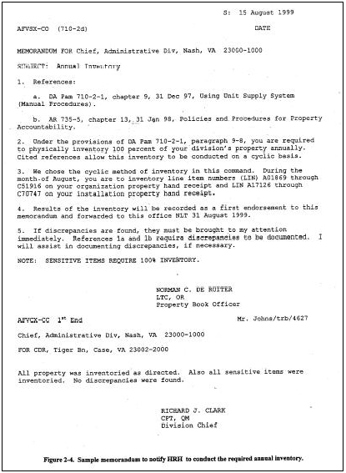
Figure 2-4

2-9. Disposition of Supplies and Equipment (other than clothing). Disposition of items means turning them in or transferring them to other activities (see Paragraph 6-5 for vehicles). To turn-in or dispose of Cadet Command property, agencies must comply with AR 710-2, Paragraphs 2-13 and 2-28c; and DA Pamphlet 710-2-1, Chapter 3. See specific procedures and additional instructions. Complete the following actions:
a. Report serviceable excess items to the Brigade. The Brigade will attempt to redistribute excess items within before sending a list of these items to Cadet Command. Cadet Command, Resource Management (Logistics) will advertise all serviceable excess items.
b. Brigade commanders with jurisdiction over both the losing and gaining organizations may approve lateral transfers. Forward all other lateral transfer actions which cannot be approved by brigade to Cadet Command for approval.
c. Dispose of cadet clothing and OCIE clothing type items at the unit per instructions for informal clothing/OCIE accountability procedures.
2-10. Cadet Clothing
a. Except for commutation schools (Paragraph 2-11 below), stock at ROTC battalions (SROTC/JROTC) and issue to enrolled cadets the authorized clothing items identified in CTA 50-900, Tables 1 and 2, (allowances recorded under column heading "ROTC RPA"). Do not stock cadet clothing items for, nor issue them to, participating members of the ROTC Simultaneous Membership Program (SMP) except for some outer garments requiring shoulder sleeve insignia. ROTC RPA funded cadet clothing is exempt from formal property book accountability per AR 710-2, Paragraph 2-5. Also, see AR 700-84, Chapter 9, for additional guidance.
b. The PBO/MPC maintains informal record keeping of cadet clothing using CDT CMD Form 146-1R (Clothing/OCIE Property Record). See Figure 2-5 below for a sample of a completed form. Adhere to U.S. Army Medical Command's policy on management of non-recoverable clothing items.

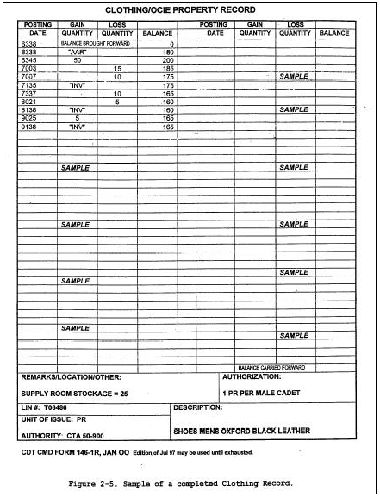
Figure 2-5
c. Use DA Form 3645-1/2 (Additional Organizational Clothing and Equipment Record) to hand receipt clothing items to authorized cadets (see sample at Figure 2-6 below).

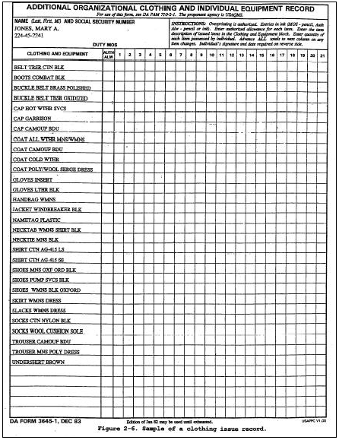
Figure 2-6
d. Clothing disposal.
(1) Serviceable clothing must be reported to the brigade for cross-leveling and/or disposition instructions. Disposing of serviceable clothing will be done IAW DA Pam 710-2-1, Paragraphs 3-6 and 3-14.
(2) Unserviceable clothing (all clothing items are identified in the AMDF as reparable code "Z" items) will be disposed of at the ROTC unit as scrap IAW DA Pam 710-2-1. PBO/ MPC/PHRH will use DA Form 3161 to record and certify items and quantities being disposed of as scrap. The PMS and HOEI will sign the DA Form 3161 to verify quantities and condition of clothing. Assign an expendable document number, complete the document register entry, post lost quantities from the informal record, and retain a completed copy on file until disposition instructions are provided.
2-11. Commutation of Uniforms. Commutation is the monetary allowance paid to SROTC cadets in lieu of issuing cadet clothing at those military colleges (MC)/military junior colleges (MJC)/civilian colleges with a corps of cadets listed in AR 700-84, Table 10-1. For proper management, comply with policy and procedures in AR 700-84, Chapter 10 and DOD DIRECTIVE 1215.8.

2-12. Authorized Sales and Purchases of Military Clothing. In certain instances, the civilian faculty members at MC/MJC/etc., and JROTC instructors (retired military personnel), may be authorized to purchase clothing items from the Army Military Clothing Sales Store (AMCSS). For retired military instructors, HQ, Cadet Command (JROTC Directorate) will provide annual certification and authority to purchase authorized military clothing items from AMCSS (see AR 700-84, paragraph 3-3i; also, Figure 2-7 below, this regulation). Per AR 700-84, paragraphs 9-1 and 9-10, the following additional guidance follows:
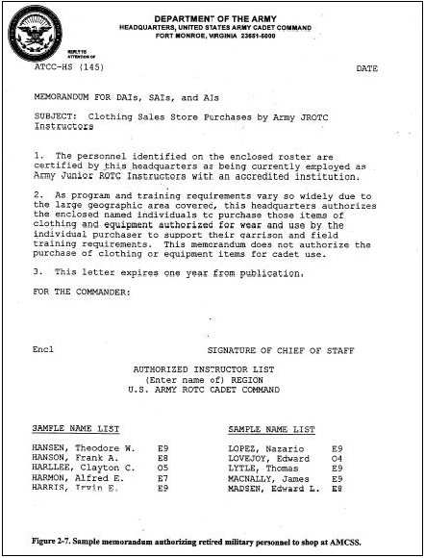
Figure 2-7
a. At institutions with no provisions for payment of uniform purchases, the purchaser remits a check or money order payable to Finance and Accounting Office (FAO) at the support installation. The PBO/MPC prepares a CCV in original and five copies IAW AR 735-5, Paragraph 12-2 (see example, Figure 2-8 below), and forwards it along with a check or money order to the FAO. The PBO/MPC prepares and submits a CCV worksheet summary on uniform purchases (attach a copy of each CCV) to brigade headquarters on a quarterly basis (negative reports are required).
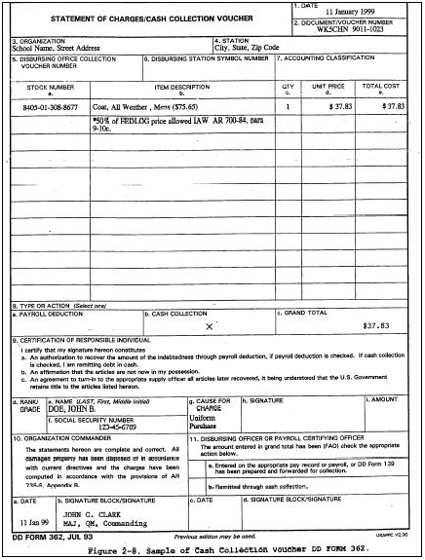
Figure 2-8
b. When an educational institution elects to purchase uniforms, they become the property of the institution. To avoid confusion, conspicuously mark non-Army uniforms to identify them as institution property.
2-13. OCIE. SROTC and JROTC units may stock and issue a limited quantity of OCIE items for field training. Only the minimum quantity essential for mission accomplishment (not to exceed the BOI in CTA 50-900, Table 4) may be stocked and issued. PBO/MPC guidance for management follows:
a. HQ TRADOC waived formal accountability of OCIE per approved waiver, WA-0393. Unserviceable OCIE, except scrap clothing items, will be disposed of IAW DA Pam 710-2-1, Chapter 3. For clothing type OCIE, use the same accounting, inventory and disposal procedures as used for cadet clothing management (Paragraph 2-10 above).
b. At the discretion of the Professor of Military Science (PMS) or HOEI, issue OCIE to authorized cadets when required for training. Hand receipt OCIE to cadets using DA Form 3645-1, 2 (Organizational Clothing and Individual Equipment Record) and DA Form 3645-1, 2 (see DA Pam 710-2-1, Figures 10-2A, 10-3A, and 10-4A).
c. Do not allow JROTC cadets and SROTC Military Science (MS)-I and MS-II to retain OCIE items unless they are participating in required training. MS-III and MS-IV SROTC cadets may retain OCIE items at the discretion of the PMS. Ensure accountability of all OCIE items after completing camp training and approved field training exercise (FTX).
d. Cadet Command uses DA Form 3645-1, 2 (Additional Organizational Clothing and Individual Equipment Record) as a hand receipt to issue cadet clothing bag items and organizational clothing and individual equipment (OCIE) to the cadets (see sample Figs. 2-6a/2-6b below which is an overview of the cadet clothing bag). Units may modify the DA Form 3645-1, 2 to add any authorized item that may be issued to a cadet (e.g. flashlights, individual training aids, etc.).

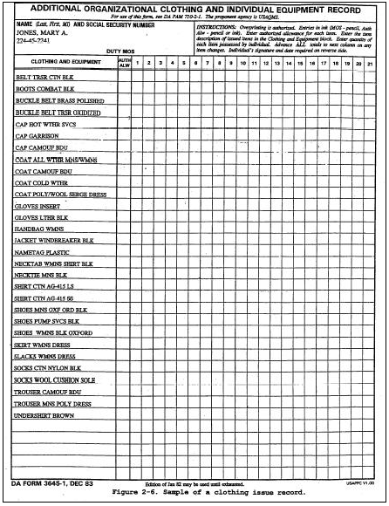
Figure 2-6a

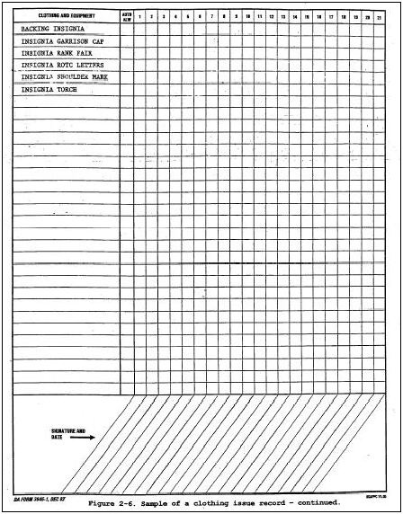
Figure 2-6b
2-14. Ammunition. Only training and ceremonial ammunition may be acquired and expended. When requesting, receiving, storing, accounting for, and turning in ammunition, the PBO/MPC complies with procedural guidance in DA Pam 710-2-1, Chapter 11, TRADOC Reg 700-2, and support installation Ammunition Supply Point (ASP) instructions. Units ensure turn-in and reconciliation of ammunition and brass residue within 90 days after completion of training event. Comply with DA Pam 710-2-1, paragraph 11-18, AR 190-11, and TRADOC Reg 700-2, as applicable, for physical security measures and the amnesty program.
2-15. Operational Rations. Meals Ready to Eat (MREs) are the standard meals authorized for SROTC field training. SROTC battalions acquire MREs when needed for field training IAW AR 30-1, AR 30-5, AR 30-18. On-hand quantity shall not exceed a one school year (SY) requirement as justified by the unit's master training schedule. Except as described below, JROTC units are not authorized MREs at government expense.
a. Authorization.
(1) SROTC Program. The Troop Issue Subsistence Agency (TISA) usually issues MREs for consumption by SROTC cadets participating in authorized field training. Cost of MRE is charged to Military Personnel Appropriation (MPA) open allotment funds.
(2) JROTC Program. Except as indicated below, the JROTC institution may purchase MREs at no cost to the government for use in the JROTC program. Acquisition will only be by "check sale" to the institution. DO NOT ACCOUNT FOR MREs ON ARMY PROPERTY RECORDS. Meals may be authorized and acquired only for an encampment at government expense by JROTC units (not to exceed one encampment per SY). An encampment must be at least four nights in duration. Accountability will be maintained by the support installation dining facility upon issue of MREs to JROTC units.
b. Request and issue procedure.
(1) SROTC Program. The PBO/MPC uses DA Form 3161 (Request for Issue or Turn-in), to request MREs from the TISA, unless another method is otherwise prescribed. Clearly identify on DA Form 3161 the specific training requirements. Cadre personnel are not entitled to free issue of rations; therefore, the battalion commander shall ensure deduction from the cadre's subsistence allowance through payroll deduction. (See Figure 2-9 below for an example.) SROTC battalions will not transfer MREs to JROTC activities.

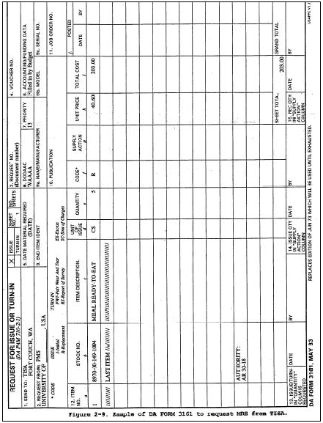
Figure 2-9
(2) JROTC Program. The support installation prescribes the procedure for JROTC units to request MREs. Usually, the TISA prepares a CCV to deposit the check from the educational institution. The institution makes the check payable to FAO in the name of the installation. DO NOT ACCOUNT FOR MREs ACQUIRED BY THE INSTITUTION ON ARMY PROPERTY RECORDS.
c. Accounting for MREs (SROTC only). MREs require 100 percent accountability. Ensure each person who eats a MRE signs DA Form 3032 (Signature Headcount Sheet), and that the headcount sheets along with DA Form 5100-R (Record of Meals Consumption) and the CCV for faculty and cadre are properly processed and forwarded to the applicable finance officer per the support installations FAO instructions.
d. Storage. See Paragraph 2-7 above.
2-16. Accounting for Lost, Damaged, and Destroyed Property. This paragraph prescribes policy regarding accountability for all property losses, damages, and destruction when it occurs in Cadet Command. Types of property included under this policy are organizational/installation (which requires formal and informal accountability), cadet clothing/OCIE (per AR 700-84, Paragraph 9-13), and GSA vehicles (per AR 735-5, Paragraphs 14-26 and 14-30). It applies to loss of, damage to, and destruction of any Cadet Command property by active duty military personnel, government civilian employees, contractor personnel, ROTC cadets (SROTC/JROTC), and educational institutions accounting for government property under bonding or insurance provisions (per AR 735-5, Chapter 10). Ensure timely processing when initiating methods of release from property accountability. The methods and circumstances for processing release from property responsibility follows:
a. Liability admitted by a responsible individual. When an active duty person, cadet, or government civilian employee admits pecuniary liability for other than sensitive items, prepare a CCV (see sample at Figure 2-10 below). The amount of collection for the specific incident (loss, damage, and destruction of property) cannot exceed the individual's monthly basic pay (see AR 735-5, Paragraph 12-2c). Process the mandatory ROS or AR 15-6 investigation IAW AR 735-5 when the incident involves a sensitive item, or when the amount exceeds the monthly basic pay.

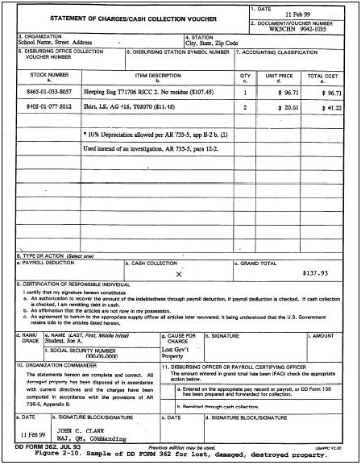
Figure 2-10
b. Educational institution accounting for government property under bonding/insurance provisions. An educational institution having accountability and responsibility for U.S. Army property reimburses the government for losses where negligence or willful misconduct is the proximate cause of the loss. Either the bond or insurance applies; or the institution reimburses the government for property lost, damaged, or destroyed (see AR 735-5, Chapter 10 and Paragraph 4-2 of this regulation). In this situation, assess an amount equal to the fair market value less depreciation. The region/brigade, in coordination with the support installation FAO representative, determines the method of collection.
c. Contractor personnel. Account for lost, damaged and destroyed property per AR 735-5, Paragraph 14-14 (Contracting officer actions on reports of survey).
d. Cadet property losses . When a cadet loses clothing and equipment, allow the cadet to reimburse the government using cash collection procedures or initiate a ROS if reimbursement is not received. In no case, will an approving authority relieve a cadet when there is evidence, prima facie or otherwise, of negligence (AR 700-84, Paragraph 9-13c(5)). See example of DA Form 4697 at Figures 2-11 and 2-12 below.
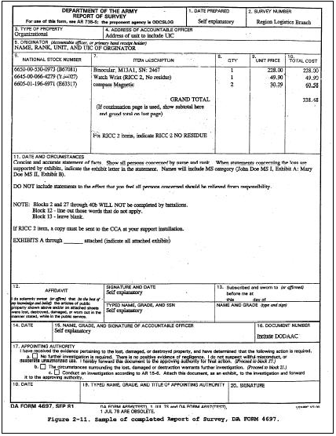
Figure 2-11

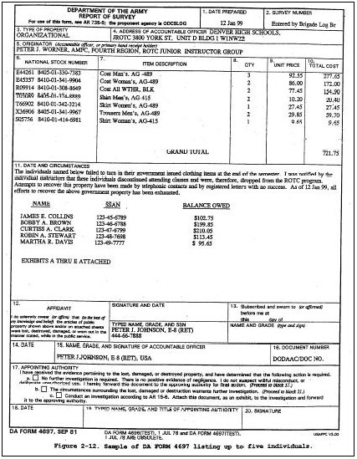
Figure 2-12
e. GSA vehicle damage.
(1) Military and civilian employees of the government, JROTC retired instructors, and contractor personnel responsible for the operation of GSA Fleet vehicles shall exercise every precaution possible to prevent accidents. In case of an accident or an incident, the employee or official concerned shall comply with the procedures established by the Federal Property Management Regulation (FPMR), Subpart 101-39.4 (Accidents and Claims) and AR 735-5, Chapters 13 and 14.
(2) Initiate a ROS method or other administrative adjustment when the GSA Fleet Management Center (FMC) that issued the vehicle advises the ROTC agency of its financial responsibility. The FMC will send a GSA Form 2556 (Miscellaneous Charges and Adjustments Transaction) to the ROTC activity based on the assigned vehicle accident or incident repair cost.
(3) Account for the cost of damages to GSA vehicles per the detailed instructions. Initiate relief action within five working days of the incident.
f. Action when liability is not admitted. Process a ROS when liability is not admitted (see sample at Figure 2-11). Make an attempt to collect under CCV or SC procedures before initiating a ROS. When CCV or SC procedures cannot be completed, ensure that initiation and processing actions occur accurately and within the established time constraints (15 working days). Consult detailed instructions.
Chapter 3, Weapons

3-1. Control of Weapons. Basic accounting and inventory procedures in Chapter 2 of this regulation applies to all weapons, authorized and on hand in Cadet Command; i.e., rifle caliber .22 and higher, air rifles and demilitarized dummy rifles (M-1 and M-1903), and howitzers. AR 190-11 establishes the security requirements for all weapons. Accounting and control of weapons in ROTC includes the following tasks:
a. Use DA Form 3161 as a control sheet or log to control the issue and turn-in of weapons within the unit.
b. In a classroom environment, do not require students/cadets to sign a control sheet when continuous surveillance/supervision exists by cadre personnel. In this instance, the instructor signs the control sheet for the total number of weapons issued.
c. Loss of accountability of weapons constitutes a serious incident and requires special reports and procedures (per AR 190-11 and AR 190-40).
3-2. Weapons Management. This paragraph sets forth the policy for weapons management in HQCC units. It prescribes the types of weapons which may be acquired and used in ROTC units. Also, it addresses the authority for them (including the BOI); and how they are initially acquired, replaced, accounted for, maintained/repaired, stored, and secured.
a. Types of weapons which may be acquired in ROTC units when approved:
b. Authorization. ROTC units must have TDA and CTA approval authority before submitting requisitions to acquire weapons (see Paragraph 2-3, this regulation for requesting changes to authorization documents). Explanation about BOI for weapons required by ROTC units follows:
(1) Rifle M14, LIN
R95114 - one per cadet in the corps at military colleges with special authority to store this category of weapons.
(2) Rifle M16, LIN, R95035 - quantity 25 required at military colleges with special authority to store this category of weapons.
(3) Rifle, cal .22, LIN R94703 - one per rifle team member NTE 15 per SROTC/JROTC rifle team.
(4) Pistol, cal .22, LIN N96193 - one per pistol team member NTE six per SROTC/JROTC pistol team.
(5) Air Rifles, LIN R45852 - one per rifle team member NTE 15 per SROTC/JROTC unit.

NOTE: The air rifle is primarily for use in the JROTC program. However, the region commander may designate the use of air rifles in SROTC units when deemed necessary because the prescribed weapon is not available, or firing ranges/facilities are not available or practical.

(6) Dummy Drill Rifles, LIN R44655.
(a) JROTC units - NTE 45 per unit unless authorized by HQCC.
(b) SROTC units - one per cadet.
(c) MC, MJC and CCWCC – one per cadet in the corps.
(7) Howitzers, Saluting, LIN K58214. NOTE: The howitzer is primarily for use at military colleges, however, in the supply system, they may be approved on an exception basis for colleges and universities when sufficient assets are available.
c. Acquisition.
(1) Weapons authorized by TDA. Ensure DA Form 4610-R (Equipment Changes in MTOE/TDA) is completed, see Paragraph 2-3c of this regulation for TDA change request. When TDA approval is granted for weapons as identified in Paragraph 3-2a above, PBO/MPC may acquire them from the source of supply using normal requisitioning procedures (per Paragraph 2-5, this regulation). Exception: Air Rifles, LIN R45852, see Paragraph 3-2c (3).
(2) Dummy drill rifles authorized by CTA.
(a) Requests for initial issue (including additional increases in authorized quantity) of demilitarized dummy rifles are to be submitted through the brigade to HQCC Management and Logistics Division. Include in the requests the unit's Department of Defense Activity Address Dode (DODAAC) and unit identification code (UIC), number of weapons requested, and the number and type weapons currently on hand. Also, this applies when requesting a replacement of the M-1903. The brigade may forward the requests to HQCC by email or fax.
(b) The item manager at Rock Island Arsenal provides HQCC Logistics the shipment information to include document number. HQCC Logistics provides this information to the brigade who passes it to the gaining unit. If the gaining unit is a hand receipt holder under an automated property book, the brigade informs the CIPBO of the pending shipment. The gaining unit notifies the Support Installation's Small Arms Serialization Surety Officer (SASSO) upon receipt of the weapons in order to properly report them to Unique Item Tracking (UIT). Also, the gaining unit provides a copy of the receipt document to brigade and to HQCC.
(c) Accomplish replacement actions of the demilitarized dummy rifles through the support installation. Unserviceable weapons which cannot be repaired must be technically inspected before turning them in and requesting replacement. Rock Island Arsenal authorizes ROTC units to strip unserviceable dummy drill rifles of all serviceable parts prior to turn-in, and to use them to maintain other rifles. The unit turns in the receiver, which has the serial number of the rifle, for property book credit and accountability. On turn-in of the receiver, the unit forwards a request for replacement using normal request procedures required by the supplying agency.
(3) Replacement acquisition for weapons other than demilitarized dummy rifles and air rifles. The ROTC unit forwards the request for replacement of all other authorized weapons (other than demilitarized dummy rifles and air rifles) to the support installation per Paragraph 2-5, this regulation.
(4) Lateral transfer of weapons. Follow the procedures as outlined in Paragraph 2-9, this regulation. Gaining and losing ROTC units provide a copy of the completed lateral transfer to the supplying agency and the installation SASSO.
(5) Exchange of M-1903 demilitarized rifles for M-1 demilitarized rifles. JROTC units replacing demilitarized M-1903 Springfield rifles with demilitarized M-1 Garand rifles must submit a memorandum to their Brigade. When approved, the rifles must be requisitioned through the supporting installation SSA. Prior to turn-in of M-1903 demilitarized rifles, the unit must ensure a technical inspection is completed by the supporting installation for serviceability and completeness. All M-1903 rifles being replaced with M-1 must be complete and in serviceable condition. JROTC units are authorized a combination of demilitarized M-1903 Springfield rifles and demilitarized M-1 Garand rifles. The combination of M-1903 and M-1 rifles will not exceed the total authorized by CTA 50-909 for rifles in a JROTC unit.
d. Receipts. The PBO/MPC shall furnish a copy of the receiving document to the supplying agency and installation SASSO NLT three working days after receipt of each weapons shipment. For receipt of initial issue of M-1s, furnish a copy of the receiving document to the brigade and HQCC Logistics.
e. Accountability and reporting. Supplying agency and PBO/MPC ensures weapons accountability per Paragraphs 2-4 and 2-5 and reports them to CBS-X and UIT per Paragraph 2-6.
f. Maintenance and Repair. Responsibility for maintenance of all weapons rests with the support installation, except as provided for in special instructions on fielding of air rifles. (See above for removal of repair parts from dummy rifles for reuse. ) Make turn-in of weapons to supplying agency personnel who will obtain disposition instructions from the item manager. Ensure appropriate coordination with, and authorization from, the supplying agency before stripping repair parts from dummy rifles.
g. Weapon storage. For authorization of storage racks, refer to CTA 50-909. PBO/MPC forwards requisitions to the supplying agency for the appropriate storage racks. Dummy rifles and air rifles are pilferable items; therefore, use storage requirements as appropriate for pilferable items. JROTC/SROTC units ensure the storage of dummy rifles and air rifles behind locked doors (including closet or separate room) with other government property.
h. Security. Rifle caliber .22 and higher. Store these weapons IAW AR 190-11.
i. Conduct the required inventory of all weapons IAW Paragraph 2-8 above.
Chapter 4, Miscellaneous Logistical Requirements

4-1. General. This chapter describes other standardized logistical requirements or actions related to the conduct of logistical management.
4-2. Bonding/Insurance
a. Educational institutions hosting ROTC units which account for government property will comply with the provisions of AR 735-5, Paragraph 10-3. Each educational institution accounting for government property must post a bond in an amount sufficient for the care and safekeeping of all government property (including uniforms) issued to the institution. Exception: Institutions hosting JROTC units may provide proof of insurance in lieu of posting a bond. In this instance, the institution provides HQCC proof of insurance in the form of an affidavit on school or board of education letterhead with the signature of the principal or similar authority. The amount of the bond or insurance must equal or exceed the total replacement value of all government property (including uniforms) entered on the initial or last annual inventory. In no case will the amount be less than $5,000 (per AR 735-5, Paragraphs 10-3 and 10-4).
b. Institutions may elect to post either a surety bond, a non-surety bond, or self-insured bond. Whichever the institution selects, the provisions of AR 735-5, Paragraphs 10-3 and 10-4 will apply regarding administration, approval and management thereof.
c. Host institution authorities must furnish HQCC (every 3 years) the reports and statements required for review of the current bond in force to ensure conformance with prescribed standards (AR 735-5, Paragraph 10-3f) (RCS exempt IAW AR 335-15, Paragraph 5-2a (4)). HOEI hosting JROTC units that furnished an Affidavit of Insurance in-lieu of bonding must renew affidavits each year.
d. IAW AR 735-5, Paragraph 10-3h, officials (HOEI) of newly approved ROTC host institutions that elect to account for government property are provided a DA Form 1622-R (Bond for Safekeeping of Government Property Issued to Educational Institutions). Also, they are provided a DA Form 1622-1-R (Affidavits of Individual Sureties), as amended under Section 47 or Section 55C of the National Defense Act of June 3, 1916. The minimum coverage required is $5,000.
e. For newly established JROTC programs, school officials must provide the completed bonding and/or insurance documents prior to the issuance of a UIC or DODAAC required for ordering government property, supplies, and equipment.
f. The annual renewal of insurance affidavits and triennial review of bonds in force will be coordinated through the brigade headquarters. This procedure maintains the required continuity and helps to ensure prompt completion of all actions required.
4-3. GSA Customer Supply Center Account. When approved by the support installation, ROTC agencies may establish a "telephone call-in" account with the respective area GSA customer supply center. When this occurs, the following applies:
a. The support installation commander allocates the ROTC agency a specific amount of Operation and Maintenance, Army (OMA) funds to purchase expendable supplies. Do not exceed allocations without approval of the support installation. Except for the last quarter in the FY, funds remaining at the end of a quarter will be carried over into the next quarter. The ROTC agency will:
(1) Establish and maintain a file of GSA cash register receipts showing expenditures for all supplies purchased. File receipts in sequence by date with the oldest document filed first (in back) in the file. Attach documents smaller than 8-1/2 by 10 inches to bond paper to prevent loss.
(2) Establish and maintain a simple monetary credit ledger (see sample at Figure 4-1 below) showing purchases, credits, and current balance of funds in the GSA account.
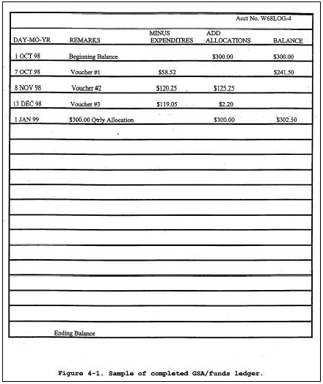
Figure 4-1
(3) On receipt of bills at the ROTC agency, complete the following actions:
(a) Verify the bills with register receipt copies.
(b) Sign and date the bills.
(c) Forward the bills to the support installation.
b. Activities found abusing their GSA shopping center account may lose such privileges.
4-4. Fuels (Diesel/Motor Gasoline). This paragraph applies to ROTC agencies receiving fuel support for transportation motor pool (TMP) vehicles or non-tactical vehicles (NTV) borrowed from other agencies such as NG, United States Army Reserves (USAR), support installation, etc. Cadet Command sends RPA dollars for transportation to include fuel to the support installation for execution.
4-5. Supply Training. Commanders should encourage military and civilian supply personnel to enroll in supply courses. DA Pamphlet 351-20 provides guidance for enrolling in residence and correspondence courses.
4-6. Interservice Support Agreement (ISA). Guidance for establishing a support agreement is contained in AR 5-9 and DOD Directive 4000.19-R. See ISA instructions.
4-7. Heraldic Items. Approved heraldic items (such as distinctive shoulder sleeve insignia, institutional unique flags, etc.) will not be purchased with appropriated funds (APF). Authority to purchase heraldic items is limited to two possible sources (specific statutory authority and CTA authority). Heraldic items do not fall within either authority; therefore, the use of APF to purchase them is inappropriate. Items with a unique design for a specific school will not be purchased using government funds. Only standard items such as Cadet Command crests and guidons can be purchased using government funds. Forward all new designs through the brigade to Cadet Command for endorsement and submission to the Institute of Heraldry.
4-8. Logistics Filing System. The ROTC agency establishes and maintains logistics files IAW AR 25-400-2.
Chapter 5, I.M.P.A.C.® Government Services Card Procedures

5-1. General. This chapter provides guidance and procedures for use of the I.M.P.A.C.® purchase card to acquire supplies and services that are commercially available and have been approved for local purchase.
5-2. Responsibilities. The I.M.P.A.C.® purchase card is an essential element in purchasing government supplies and services. Card holders and Approving Officials must possess the highest ethical standards, and follow the prescribed acquisition guidance of the support installation when making purchases with the I.M.P.A.C.® card. The following emphasizes several prescribed procedures required of card holders and Approving/Certifying Officials to ensure proper management and control of I.M.P.A.C.® purchase transactions:
a. Card holders and Billing/Certifying Officials must follow their support installation's most current SOP to ensure each transaction meets the legal requirements for an authorized purchase.
b. Billing/Certifying Official's grade must be equal to or greater than the cardholder.
c. The cardholder must safeguard the I.M.P.A.C.® purchase card and account number at all times. Therefore, never leave the I.M.P.A.C.® in a place easily accessible to a nonuser (i.e., safe, locked drawer, etc.).
(1) Only the cardholder is authorized to use the card.
(2) Each card bears the assignment of a unique account number--one account per card.
(3) Make certain you have a copy of both the cardholder and billing official appointment orders.
(4) Billing/Certifying Official reviews and validates all purchases and supporting documentation.
d. Card holders must maintain a comprehensive register/log of all I.M.P.A.C.® purchases and the supporting documentation for each transaction. Each ROTC cardholder still on a manual billing system must use the reproducible ROTC CDT CMD Form 445-R (I.M.P.A.C.® Purchase Card Log) (Figure 5-1 below) in order to ensure proper recording of the same information for each ROTC cardholder’s I.M.P.A.C.® purchase. Card holders using the automated CARE system must maintain the purchase log on the CARE web site.

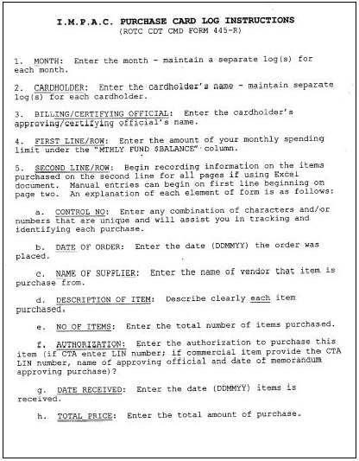
Figure 5-1

e. Billing/Certifying Official ensures establishment of property book and hand receipt accountability when a cardholder purchases a property book (non-expendable) or a hand-receipt (durable) item.
f. Account Reconciliation - Manual Billing System:
(1) The cardholder reviews and reconciles the Statement of Account (SOA). Ensure each transaction includes adequate documentation (receipts, written description of each item, shipping documents etc.) before submitting it to the Billing/Certifying Official for validation.
(2) Billing Official forwards the certification statement and the SOA to DFAS by the fifteenth calendar day following receipt of the Billing Statement. Follow the guidance for payment provided by the support installation contracting office. Failure to return the statement promptly may result in the Army having to pay additional charges associated with the Prompt Payment Act.
g. Account Reconciliation - CARE System:
(1) Cardholder reviews and approves purchases on-line. Ensure each transaction includes adequate documentation. Approve monthly statement within three (3) working days of end of billing cycle. Present month's transactions, with documentation, to billing official.
(2) Billing official reviews documentation of card holder(s) and certifies entire statement. Approval by cardholder and certification by billing official should all be accomplished within five (5) working days of end of billing cycle.
h. Billing/Certifying Official maintains a purchase card file and all support documentation for 6 years.
i. Disputes must not cause the statement(s) to be delayed; therefore, follow support installation's SOP guidance to resolve disputes. The cardholder will attempt to resolve the dispute with the vendor. If there is no satisfactory resolution, the cardholder has 60 days from the date of the statement to submit a copy of the statement with an explanation of the circumstances directly to the bank for resolution.
j. Card holders and Billing/Certifying Officials must attend mandatory I.M.P.A.C.® training to ensure they remain current and up-to-date on changes to the program. The support installation schedules the training.
k. Card holders and Billing/Certifying Officials will adhere to requirements of the Management Control Program. They utilize the checklist for the government purchase card program to ensure proper internal control.
l. Card holders ensure they accomplish the following:
(1) Obtain required prior approvals in writing before purchasing item(s).
(2) Use the mandatory sources provided in support installation SOP and Paragraph 5-3.
(3) Check to ensure availability of monthly funds.
(4) DO NOT SPLIT ORDERS to fall within the $2,500 expenditure limit for a single purchase ($2,000 for construction). Single purchase may include multiple items, but the total amount may not exceed the single micro purchase limit.
(5) DO NOT pay state or local taxes on card purchases.
(6) Coordinate purchases with the appropriate process owners (Directorate of Information Management (DOIM), Directorate of Public Works (DPW), etc.).
(7) Only purchase authorized mission essential items using the card IAW service/agency policies, regulations, or authorization document (CTA).
(8) Notify PBO to account for non-expendable durable items.
(9) Adhere to the support installation acquisition guidance.
m. Bonded university/college employees and contracted employees cannot be IMPAC credit card holders or IMPAC Approving/Billing Officials.
5-3. Unauthorized Purchases and Supply Sources. Before deciding to use commercial sources, the cardholder determines if mandatory sources meet the need. Numerous office supply type items and furniture are to be purchased through a mandatory source.
a. Mandatory sources are:
(1) Activity/installation inventories (office supplies maintained in a Self Service Supply Center or excess items maintained by local supply community).
(2) Federal Prison Industries (UNICOR)(furniture).
(3) National Industries for the Blind/Severely Handicapped (NIB/NISH) (office supplies, medical supplies, plastics, textiles, industrial products such as paints and cleaners). These items are available to government activities through GSA, Defense Logistics Agency (DLA), or specific contractors authorized to order from GSA.
(4) Department of Defense (DOD) Wholesale supply sources.
(5) Authorized CTA items.
b. Monthly Funding. Ensure that total cumulative dollar value of all purchases do not exceed the monthly spending limit established by your support installation.
c. Purchase Problem(s). Approving Official should identify the appropriate cardholder; describe the purchase problem(s) and provide this information to the immediate higher headquarters (brigade, region, and HQCC). The higher headquarters will take disciplinary and/or corrective action when necessary.
5-4. Purchase Restrictions
a. Unauthorized Use. Units must adhere to the guidance and procedures outlined in this chapter. Also, they must adhere to the support installation's SOP that may be more restrictive. GSA imposes the only absolute restrictions on the use of the I.M.P.A.C.® purchase card. They are as follows:
(1) Cash advances (includes money orders);
(2) Long-term rental or lease of land or buildings;
(3) Telecommunication (telephone) services (e.g., major network services like FTS2000, DSN, DISN or dedicated voice and data circuits).
b. Controlled Purchases. The I.M.P.A.C.® purchase card cannot be used to obtain the following items without the specific approval from the supply system Integrated Material Manager. When required, the installation Director of Logistics (DOL) obtains approval for the customer regardless of payment method:
(1) Weapons system related items.
(2) Handguns, firearms and other sensitive items; and Hazardous materials such as chemicals, ammunition and explosives.
c. Conditional Use. Items or services not identified as restricted or controlled above may be potential candidates for acquisition with the purchase card when the process owner (e.g., DOIM, DOL, DPW, etc.) grants local purchase authority. However, if the requirement is not relatively "straight forward" and "non-complex" in nature (i.e., in the case of some repair services), it should probably be forwarded to the Director of Contracting for purchase. In this case, if the value of the acquisition is under $2,500, it should be accompanied by an explanation of why it cannot be obtained by the cardholder. Some examples of the type items or services that might be obtained via the purchase card are:
(1) Short term government vehicle leases (not for personal temporary duty travel (TDY) use) (process owner DOL).
(2) Senior ROTC Cadre using leased vehicles and not on travel orders may use to pay for gasoline refills (only cardholder is authorized to use card).
(3) Items normally available in the DOD wholesale supply system, but time of expected delivery and cost will jeopardize satisfactory completion of mission requirements (process owner DOL).
(4) Travel-related expenses:
(a) Purchase of travel related tickets such as airline, bus, boat, train or other travel related tickets (process owner DOL)
(b) Purchase of meals, lodging or other authorized travel subsistence expenses (process owner DOL).
(c) Use to the maximum extent practical, other types of credit cards for travel purposes (i.e., the Government Nations Bank VISA card). Although the I.M.P.A.C.® purchase card is not intended for use to pay for travel-related expenses, it is possible to use the card for travel purposes when:
1. Specifically authorized under the merchant activity type code.
2. Non-acceptance of the mandatory GSA travel and subsistence card and when the traveler has specific written permission from his/her supervisor and/or approving official.
(5) The cardholder presents the vendor with a copy of published orders as proof of official travel status and a tax-exempt form for eligibility for state and local tax exempt status. However, there are states that do not recognize travelers on official duty as "tax exempt." In these cases, the traveler claims the tax portion of the bill on his travel voucher. Upon use of the purchase card, the cardholder and his/her supervisor and/or Approving/Certifying Official ensures that the cardholder does not claim the amount charged on the purchase card on his/her travel voucher. Further, identify in the remarks section on the voucher what was paid for with the card.
(6) Under the U.S. Government car rental agreement program, the I.M.P.A.C.® purchase card is not considered acceptable proof of official travel status, nor is it honored as a payment method.
(7) Some examples where it may be appropriate to use the purchase card subject to above conditions:
(a) In support of the DOD Information Program for International Military Students.
(b) Meals for service members during reserve training.
(c) Meals for members of casualty details.
(d) When administrative cost of preparing/processing travel orders and vouchers exceeds amount of funds to be reimbursed to the traveler.
(e) Meals provided for installation visitors at official functions when it is otherwise appropriate for protocol purposes.
(8) Purchase of gasoline or oil for vehicles except: aircraft, vessels, and department owned vehicles (process owner DOL).
(9) Repair of GSA Fleet leased vehicles (process owner DOL). Customers of the GSA Fleet Management Program who use the U.S. Government Fleet Services Card to pay for services, maintenance, and repair to GSA Fleet vehicles shall not use the I.M.P.A.C.® card in lieu of this card to pay for those same purchases without specific approval of the process owner.
(10) Mission essential personal clothing or footwear (e.g., safety shoes, safety glasses, etc.)(process owner DOL).
(11) Printing or copying services. Statutory and regulatory restrictions govern commercial procurement of printing regardless of the method of payment. Procure printing services from the Defense Automated Printing Service (DAPS), which is the acceptable and encouraged method to use the I.M.P.A.C.® card for payment (process owner DOIM, but requires no pre-approval when obtaining printing from DAPS).
(12) Construction (not to exceed $2,000), alteration, or repair of real property (process owner DPW/ENG).
(13) Short-term rental or lease of land or buildings (e.g., for deploying units which need office space for a month) (process owner DPW/ENG).
(14) Janitorial, yard and maintenance services valued at under $2,500, if these services are not available under an existing base operations service contract (process owner DPW/ENG).

(15) Automated data processing and telecommunications supplies, software, equipment and repair and/or other services (process owner DOIM). Software loaded on Senior and Junior units' computers must be authorized according to Information Management Office, HQCC guidance. I.M.P.A.C.® card may not be used to pay for contractors to develop software.
(16) Payment of telecommunications (telephone) services under an existing intergovernmental or installation service contract (process owner DOIM).
(17) Audiovisual aids or equipment (process owner TASC or Post AV).
(18) Use purchase requests to acquire unit guidons, flags, and battle streamers when approved by the Institute of Heraldry; and also, use a purchase request to acquire unit coins when authorized, through the chain of command by HQ TRADOC. Use of I.M.P.A.C.® cards for these purchases is not authorized.
(19) Supply support activity (SSA) authorized stocked items, if out of stock or estimated delivery date will not meet immediate requirements (process owner DOL).
(20) Personalized or promotional items (e.g., commander's coins) approved for purchase with appropriated funds (process owner CG or protocol).
5-5. Misuse of the I.M.P.A.C.® Card. Intentional use of the card for unauthorized purposes will be considered an attempt to commit fraud against the U.S. Government. Unauthorized use of I.M.P.A.C.® will result in immediate cancellation of the card and disciplinary action against the cardholder, ranging from reprimand to removal. A cardholder that intentionally misuses the card may be held personally liable to the government for the amount of the unapproved purchases. Misuse of I.M.P.A.C.® by the cardholder may be subject to a fine of not more than $10,000, or imprisonment for not more than five (5) years, or both, under applicable provisions of Title 18 of the United States Code.
5-6. Semi-Annual Audit Procedures. (Purchase logs requiring review may be on ROTC CC Form 445-R or printed reports from the CARE system.).

a. Headquarters Cadet Command.
(1) Review each region's purchase logs semiannually.
(2) Request additional information from region(s) on purchase(s) if necessary.

b. Region Headquarters.
(1) Provide HQCC the region headquarters' previous six months purchase logs not later than 60 days after the end of last month. For example, first set of logs (October – March) should be at HQCC not later than 31 May. Second set of logs (April – September) should be at HQCC not later than 30 November.
(2) Designate a region program manager or representative. Manager or representative must not hold a lower rank/grade than the Billing/Certifying Official.
(3) Furnish the name, rank/grade and phone number of the region program manager to HQCC.
(4) Furnish HQCC with the name, rank/grade and phone number of each region headquarters cardholder along with each cardholder's approving official’s name, rank/grade and phone number.
(5) Monitor each cardholder's monthly spending limit.
(6) Provide HQCC the following information semi-annually after review of each brigade's log(s):
(a) Name of brigade.
(b) Number of Senior Units brigade reviewed.
(c) Number of Junior Units brigade reviewed.
(d) Description of any purchase problem(s) and the brigade or school name.
(e) Action taken to correct any problem.
(7) All Senior and Junior unit purchases must be reviewed (100 percent audit).

c. Brigades.
(1) Semiannually review your senior and junior schools' purchase logs. The review may be accomplished by either Command Inspection, support installation visit (Command Supply Discipline Program (CSDP)) or by requesting copies of logs.
(2) Provide your region the following:
(a) Your brigade headquarters purchase logs semiannually.
(b) The number of schools reviewed (all Senior and Junior units MUST be reported).
(c) Description of any purchase problem(s).
(d) Explanation of action taken to correct problem.
Chapter 6, GSA Vehicle Fleet Management

6-1. General. This chapter provides policy and procedures for managing GSA Fleet vehicles assigned to all elements of the U.S. Army Cadet Command.
6-2. Vehicle Authorizations
a. TDA requirements for mission-use vehicles. ROTC agency's mission-use vehicle requirements must be documented on the TDA IAW AR 71-32 (see Paragraph 2-3 of this regulation for general guidance). Mission-use vehicles are categorized as permanent long-term use vehicles required for 60 days or longer. Authorizations for mission-use vehicles are limited to the minimum number needed to provide essential motor vehicle transportation services under normal conditions. The type vehicles to be documented on the TDA are listed in Table 6-1 (below) and the sedan and station wagon classifications by the ROTC agency are listed in Table 6-2 (below). Table 6-3 (below) shows the vehicle life expectancy, and Table 6-4 (below) reflects justification criteria.
b. Requests for initial and additional vehicles. Requests for new and additional vehicles will be justified on DA Form 4610-R and submitted by memorandum through the battalion commander and to the brigade commander. The memorandum must include a statement that a brigade vehicle fleet analysis was accomplished. The request will be forwarded to HQCC (ATCC-RM) for approval and final action. Use justification criteria for vehicles in Table 6-4 (below).
c. Temporary short-term (less than 60 days) requirements. Special requirements for temporary short-term vehicles, such as, surge requirements, FTX support, hazardous material (HAZMAT) transportation, TDY use, and vehicle replacement (for an assigned vehicle down for maintenance or accident repair) are not documented on the TDA, and do not count against HQCC total vehicle allocations. Instructions on how to obtain a short-term use vehicle is provided under GSA Fleet Management Acquisition of GSA Vehicles.
6-3. Vehicle Asset Allocations. All vehicle requirements are allocated by the CGCC from annual resources made available by TRADOC.
Table 6-1

Vehicle Classifications

Use this table for determining mission-use vehicle requirements. Only the minimum number, by type of vehicles needed to support the agency's mission, will be authorized. Use the following GSA vehicle classifications cross-referenced with SB 700-20 LIN to determine the type vehicles to document in TDA Section III (equipment).
VEHICLE TYPE | GVWR | GSA CLASS | SB 700-20 LIN
Sedan, Midsize | N/A | 1100 | BO4715
Sedan, Compact | N/A | 1200 | BO4441
Sedan, Subcompact | N/A | 1300 | BO4441
Station Wagon, Compact | N/A | 2100 | BO4832
Van, Cargo | Under 6,000 | 4110 | X42064
Van, C/A (5-7 Pax) | Under 6,000 | 4115 | X42064
Trk, Compact P/U Reg Cab | Under 6,000 | 4120 | X39598
Trk, Standard P/U Reg Cab | Under 6,000 | 4150 | X39598
Trk, Standard P/U Extd Cab | Under 6,000 | 4151 | X39598
Van, Cargo | 6,000-8,499 | 4210 | X42064
Van, C/A (8-11 Pax) | 6,000-8,499 | 4215 | X42064
Trk, P/U, 2-Dr | 6,000-8,499 | 4250 | X39598
Trk, Standard P/U, Extd Cab | 6,000-8,499 | 4251 | X39598
Van, C/A (12-15 Pax) | 8,500-12,499 | 4315 | X42064
Trk, P/U, Crew Cab | 8,500-12,499 | 4352 | X39893
Van, Delivery, Cut-Off Cab | 8,500-12,499 | 4365 | X62751
Van, Multi-Stop (FC) Trk | 8,500-12,499 | 4366 | X54531
Van, Passenger, 4x4 | Under 6,000 | 6115 | X54805
Trk, P/U, 2-Dr Cab, 4x4 | Under 6,000 | 6150 | X39893
C/A, Conventional 4x4 | Under 6,000 | 6175 | X42201
Trk, P/U, 2-Dr Cab, 4x4 | 6,000-8,499 | 6250 | X39893
C/A, Conventional 4x4 | 6,000-8,499 | 6275 | X42201
Trk, P/U, Crew Cab, 4x4 | 8,500-12,499 | 6352 | X39893
C/A, Conventional, 4x4 | 8,500-12,499 | 6375 | X42201
Trk, Cab W/Van Bdy, 4x2 | 17,000-20,999 | 7410 | X61792

Public law stipulates that Class IA, IB or Class II vehicles be used to meet daily mission requirements. When Class I or Class II sedans clearly do not meet mission requirements, an exception may be granted to document Class III or higher vehicles on the TDA. In this instance, forward requests for class III or higher vehicles to HQCC (ATTN: ATCC-RM). Include the following information in the justification:
a. The intended use of the vehicle. Will the vehicle be used for domicile-to-duty or command and control purposes? If so, has approval been obtained? Who will be the driver?

b. Provide a clear statement of why a smaller vehicle will not meet mission requirements. Class III or higher vehicles will not be authorized based on position, rank, or personal preference.

Table 6-2

Sedan and Station Wagon Classifications
VEHICLE TYPE | CLASSIFICATION
Subcompact Sedans | IA
Subcompact Station Wagons | IB
Compact Sedans | II
Compact Station Wagons | II
Midsize Sedan | III
Large Sedan | IV
Large Station Wagon | IV
Limousine | V

Table 6-3

Vehicle Utilization Life Expectancy Guidelines
VEHICLE TYPE | YEARS | MILES
Sedans/Station Wagons | 3 and | 36,000
 | Or 4 and | Any
 | Or Any and | 60,00
Light Trucks/Vans  (4x2, 4x4) | 6 or | 40,000
 | Or 7 and | Any
 | Or Any and | 60,000
Medium Trucks/Vans (4x2, 4x4) | 10 or | 100,000

Table 6-4
Justification criteria for vehicles.
ROTC activity checklist to request a change of vehicle authorizations.
a. Justification: Justification for an initial/additional full-time vehicle assignment or vehicle upgrade must contain the following information:
(1) Requester name, address, phone/fax number, e-mail address.
(2) Purpose/reason for need. Accessory equipment/modifications/cost.
(3) *Additional/upgrade vehicle type needed (DA Form 4610-R attached).
(4) Estimated mileage. Do miles meet criteria (AR 58-1, Fig 2-1)?
(5) Mileage does not meet criteria, justify as mission essential.
(6) Number of cadets, cadre, schools supported. School template?
(7) Estimated tonnage/pieces of cargo transported monthly/yearly.
(8) Number/location/distance to partnership schools supported.
(9) Number/location/distance to JROTC programs/supported.
(10) Number/location/distance to training events, ceremonies, etc.
(11) Number of trips/location/distance to support installation per-wk.
(12) Estimated cost of requested vehicle. Will there be an offset?
(13) Vehicle modifications/accessory equipment required? Cost?
(14) Number/type of vehicles currently assigned/authorized.
(15) How has this requirement been supported in the past?
(16) Is the vehicle requested the smallest, most fuel-efficient type?
(17) Why can't support be obtained from a short-term dispatch vehicle?
(18) IF CC approves/funds, estimated date GSA can support requirement?
(19) Is the requested vehicle upgrade scheduled for FY replacement?
(20) Are Alternative Fuel Vehicles (AFV) ordered as replacements?
(21) Impact statement if vehicle request is not approved.
*SUV’s/Mid-Size Sedans require special authorization (AR 58-1, Para 2-9, 3-6).
b. Brigade vehicle fleet analysis checklist. Perform a brigade vehicle fleet analysis for all change of vehicle authorization requests. Failure to indicate that this analysis was performed will result in disapproval of the request. The following information is provided for use during the analysis:
(1) Does the justification include the vehicle TDA status of the proposed user?
(2) Does the justification fully explain the proposed use of the vehicle? Is this requirement seasonal or sporadic? Can it be satisfied by a short-term lease or rental to prevent investing in a new vehicle (reference DOD 4500.36-R, Para 3-6b)?
(3) Is the type of vehicle requested the most suitable for the task, or can the vehicle be downsized to a smaller, less expensive, more fuel-efficient vehicle that will do the same job?
(4) By analyzing the brigade vehicle fleet assignments, is there a low mileage, lower priority vehicle that can be transferred from another activity to satisfy this requirement? Is a statement included with the battalion request that a brigade analysis was performed?
(5) Is there an activity vehicle TDA authorization (that does not have a vehicle assigned against it) that can be transferred to support this new requirement?
(6) How has this requirement been supported in the past? Why can't the present support continue?
(7) Does the request indicate the directive, project, or mission change (cadet enrollment increase, template change, extension center became a host, etc.) that generated the request?
(8) Does the justification state why transportation support from their support installation TMP (UDI) or co-utilization from other Government agencies (Navy/AF ROTC/NG/Reserves) will not meet mission requirements?
(9) Does the justification provide the monthly cost and use of the requested vehicle? Modifications or accessory equipment costs? Is there a cost offset?
(10) Are towing hitch/lightport accessory equipment authorizations for assigned van carryalls encouraged in place of approving pickup truck authorizations to transport cargo, supplies and HAZMAT to support FTX's?
(11) Does the justification identify expected monthly utilization information (miles, number of passengers, equipment, supplies transported, number of trips, tonnage, etc.)? Does estimated mileage meet the minimum monthly standards? If not, does the justification state the vehicle is mission essential?
(12) Does the justification include a mission impact statement of the activity if the request is denied? Did the Brigade Commander/XO approve the request?
c. CC vehicle fleet analysis. IAW Title 40 U.S.C. Section 491, only the minimum number of vehicles necessary to support the mission should be authorized. Each of the following questions must be addressed in the affirmative and answered before the request can be processed for an authorization change
(1) Does the request fully explain the proposed use of the vehicle? Is the request signed by the Activity Commander and approved by the Brigade Commander or Executive Officer?
(2) Does the request include a statement by the Brigade Vehicle Fleet Manager (BFM) indicating that a brigade vehicle fleet analysis was performed? Does the statement indicate that there are no excess authorizations, low utilization or lower priority vehicles available within the brigade vehicle fleet to transfer to support the new requirement?
(3) Verify that the number and type of vehicles assigned match the vehicles that are authorized on the current vehicle Table of Distributions and Allowances (TDA). Verify the school template against number of vehicles assigned/requested.
(4) Identify the average 12-month utilization of the assigned activity vehicles. Verify that the vehicles meet the utilization criteria by vehicle by (AR 58-1, Fig 2-1). Are the vehicles not meeting the desired utilization criteria justified on mission essentially?
(5) Review the GSA Motor Vehicle Schedule to see if there is a vehicle type that is more suitable for the task, or can be downsized to a smaller, less expensive, more fuel-efficient vehicle type that will do the same job then the vehicle that is requested?
(6) Ensure request for vehicle accessory equipment or modifications are authorized vehicle changes (TM 38-600, Appendix G).
(7) Forward requests for SUV’s, 4x4 over 5,0000 GVWR to MACOM for approval (AR 58-1, Para 2-9).
(8) Forward requests for Class III (midsize) sedans to HQDA/Sec of Army for approval (AR 58-1, Para 3-6e).
(9) Ensure vehicle replacement requests are in compliance with the Energy Policy Act (EPACT) concerning requirements to replace vehicles with Alternative Fuel Vehicles (AFV) in certain Metropolitan Statistical Areas (MSA) (AR 58-1, Para 2-8).
(10) Forward requests to ATCC-RP for funding and the RM for TDA Vehicle authorization change approval.
6-4. Acquisition of GSA Vehicles. Mission-use long-term, temporary/ short-term, and seasonal and special requirement vehicles. ROTC agencies will only acquire long-term vehicles authorized on the TDA. When long-term vehicles are not available, GSA will notify the ROTC agency which will take action IAW procedures under GSA Fleet Management.
6-5. Accountability and Disposition of Assigned GSA Vehicles
a. GSA will assign the vehicle and ancillary items (spare tire, jack, lug wrench, driver package, credit card, and snow chains) to the ROTC agency on a hand receipt, GSA Form 1152 (Vehicle Assignment/Termination). GSA long-term assignment vehicles will be accounted for on the organizational property book (DA Form 3328) or the support installation property book as applicable. The property book will provide an audit trail for the authorization of the agency’s GSA vehicles. If a manual property book, the agency’s supply representative will prepare a DA Form 3328 for each type vehicle on the TDA; however, do not enter the balance on hand. Make an annotation on DA Form 3328 that states "see GSA fleet long-term assignment vehicle files."
b. Disposition of assigned GSA vehicles involves vehicle retention, rotation, acquiring substitute vehicles, replacement, transferring, and loan to other federal agencies. For specific procedures in these areas, see under GSA Fleet Management.
6-6. U.S. Government Fleet Services Card Management. A U.S. Government Fleet Services Card, provided by Voyager Corporation, is issued by the GSA FMC with each assigned mission-use vehicle. The ROTC agency must exercise care to ensure judicious use of credit cards. Use the card only for the vehicle for which it is assigned (the vehicle license plate number is embossed on the bottom left hand corner of the card).
(1) Fuel purchases. Purchase unleaded regular grade only, unless the vehicle uses alternate type fuels, in which case follow the instructions given by the supporting FMC. Use of premium grade fuel is not authorized unless the vehicle’s engine specifications require it. Use of full service pumps and/or purchasing premium fuel will be charged-back to HQCC at the full service and/or premium fuel prices plus the addition of a 10 percent service charge. This is an unauthorized purchase and the driver may be held liable. The following are valid exceptions to using self-service pumps:
(a) Self-service pumps are not available at an authorized service station.
(b) Physical limitations of the vehicle operator.
(c) Severe weather conditions.
(d) The cost of fuel at full-service pumps is the same or lower than the cost of fuel at the self-service pumps.
(e) State law prohibits the use of self-service gas pumps.
(f) Service station refuses to honor the U.S. Government Fleet Services credit card for fuel pumped at self-service islands. Before pumping fuel, see if the pumps have a Voyager Corps logo on them. If the pumps do not reflect this logo, ask the service station attendant if the government credit card will be accepted. This will prevent the vehicle operator from paying cash out of pocket and having to request reimbursement (SF Form 1164, Claim for Reimbursement for Expenditures on Official Business) at a later date.

(2) Use of the access code. Know the access code before purchasing fuel with the U.S. Government Fleet Services Card (it is the last 5 digits of the vehicle license number that is embossed on lower left side of the credit card). For electronic sales, enter the access code into the station keypad when the prompt on the keypad reads "enter Pin Number or Driver ID." When prompted, enter the vehicle's current odometer reading. For manual sales, write the access code and the current odometer reading on the ticket.

(3) Other authorized purchases using the U.S. Government Fleet Services Card. Use the credit card to purchase other needed items such as oil, windshield wiper blades, a headlight, washer fluid, etc. The following policy applies when specific purchases are made:
(a) Approval is required by the maintenance control center (MCC) for any repairs or non-fuel purchases that exceed $100.00 (new tires, brake repairs, battery replacements, wheel balances, wheel alignments, fuel system repairs, and shock/strut replacements, regardless of cost). GSA has consolidated MCC operations staffed by trained automotive service technicians to four locations. Calls to the MCC at 1-888-622-6344 are now being answered by GSA staff in Philadelphia, PA; Atlanta, GA; Fort Worth, TX; and Lompoc, CA.
(b) The charge limit for emergency repairs and towing is $500.00. Emergency repairs are unscheduled, unplanned repairs that take place after hours, or when it is impossible or impractical for the driver to contact the MCC or the FMC. If the U.S. Government Fleet Services Card is used for emergency repairs, mail the tissue copy of the ticket to the appropriate FMC the following duty day with an explanation of the emergency purchase.
(c) Use of the credit card is authorized to pay for washing vehicles at a commercial car wash IAW the supporting GSA FMC policy only. Reasonable cost (normally 1-2 car washes per month) is authorized. However, the location and use of the vehicle may require more frequent washes, which may be authorized by the supporting GSA FMC when requested. Whenever possible, vehicle operators should use an authorized service station that provides a free or low-cost drive-through car wash with each fill-up. Do not use U.S. Government Fleet Services Cards to have vehicles detailed and waxed. To obtain an exception to the vehicle detailing (professional vehicle exterior/interior cleaning) rule, forward a request through the Brigade Commander to Cadet Command (ATTN: ATCC-RM).
(d) Use the vehicle credit card to pay for towing if the vehicle is involved in an accident or will not start and requires vehicle maintenance service. Do not use the credit card if vehicle towing service is provided by the vehicle manufacturer. For new vehicles under warranty, call the following numbers for 24-hour roadside assistance:
Vehicle Manufacturer | Roadside Assistance Phone
Ford | 1-800-241-3673
Chevy | 1-800-243-8872
Oldsmobile | 1-800-443-6537
GMC | 1-800-462-8782
Dodge/Plymouth/Jeep | 1-800-521-2779

(4) Credit card use oversight. Credit card purchases are reviewed for usage compliance by the supporting GSA FMC and the GSA General Counsel Office. HQCC is charged when noncompliance with proper procedures occurs. Purchases that are not authorized and indicate misuse of the vehicle credit card will be directed to the ROTC agency commander, and referred for further action as appropriate. Using the credit card for other than the assigned vehicle or for personal purchases could constitute misuse and/or larceny, and will subject the user to criminal prosecution under 18 U.S.C. 641. Unauthorized expenditures at the unit will generally result in a recommendation that the responsible individual be held financially liable. A sample of unauthorized expenditures is listed below:
(a) Unauthorized credit card purchases, e.g., personal items, premium fuel, vehicle waxing (detailing), etc.
(b) Unauthorized GSA vehicle maintenance.
(c) Unauthorized GSA vehicle modifications or special accessory equipment installation.
(5) The vehicle operator must ensure that the credit card is adequately safeguarded when issued to him or her. When not issued to a vehicle operator, secure it in a locked drawer, safe, or cabinet. Telephone the GSA FMC immediately if the credit card is lost, stolen, or damaged (embossed lettering flattens, the imprint becomes illegible, or the magnetic "point of sale" strip on the reverse side of the card becomes "demagnetized"). Follow up the verbal report with a written report. Do not use the credit card after it is reported lost or stolen. GSA will order the replacement card and invalidate the lost card account number. Any charges made against a card that is found and used with an invalid account number will be billed-back to HQCC.
(6) Credit card for commercial vehicles. A credit card will not be provided when a short-term commercial vehicle is rented or the vehicle is borrowed from another DOD agency. To pay for fuel, oil, emergency maintenance, towing, etc., pay out-of-pocket and obtain reimbursement by submitting SF Form 1164 with all receipts to the activity providing funding support. An alternate method, in this instance, is to use the activity I.M.P.A.C.® credit card to pay for fuel for commercial rental vehicles. The exceptions are that the individual involved must not be on TDY orders, must be the authorized cardholder, and must be approved by the support installation DOL. When using a support installation TMP government vehicle credit card, an agreement must be established with the installation on how reimbursement will be made. |
6-7. Vehicle Dispatch Procedures. IAW TM 38-600, Para 5-8(3) DA Form 2401 (Organizational Control Record for Equipment), CC Form 215-R or a computer generated automated dispatch log may be used to manage and control the ROTC agency administrative use vehicles.
6-8. Standard Utilization Levels for Assignment of GSA Vehicles
a. The ROTC agency will justify assignment of a full-time vehicle.
b. Utilization factors such as days used, agency mission, and the relative cost of alternatives to a full-time vehicle may be considered as justification when guidelines for "miles traveled" are not met. The following general guidelines apply:
(1) Sedans/station wagons. Operate a minimum of 3,000 miles per quarter or 12,000 miles per year.
(2) Light trucks, vans, and general-purpose vehicles up to 12,500 pounds gross vehicle weight rating (GVWR). Operate at least 10,000 miles per year.
(3) Trucks and general-purpose vehicles, 12,500-23,999 pounds GVWR. Operate at least 7,500 miles per year.
c. Vehicles not meeting minimum utilization standards are subject to mandatory rotation by the supporting GSA FMC.
d. Motor vehicle average monthly utilization (miles traveled) will be reviewed annually by the CCFM to ensure effective asset assignment.
6-9. Mileage Allocation and Permissible Operating Distance (POD)
a. HQCC allocates 1,300 miles per month, per vehicle for ROTC agency's mission (including camps). The ROTC commanders will ensure that the vehicle fleets stay within the overall mileage allocation. Exceptions to exceed the unit monthly mileage limitations will be approved by the brigade commander. See under GSA Fleet Management for additional instructions.
b. A one-way distance of 100 miles is the POD for ROTC administrative use motor vehicles. Requests to exceed the POD must be approved by the brigade commander. Exceptions to the POD are listed under GSA Fleet Management.
6-10. Authorized Use of Government Vehicles. Official use of the vehicle will be authorized by the agency's commander based on need, distance involved, use that would further the mission of the Army, and other conditions that justify their use. Authorized uses of government vehicles are specified in AR 58-1, Para 2-3.
6-11. Vehicle Use Limitations, Restrictions, Penalties, Priority of Services, Rules of Operation, and Official Use Determinations. Statutory law (40 U.S.C. Section 491) requires DOD to establish an effective means to limit and restrict the use of government vehicles to official government purposes (per DOD 4500.36-R, Management, Acquisition, and Use of Motor Vehicles). This means ROTC commanders must restrict the use of all assigned government vehicles (including rented and leased), to official use only. For details see GSA Fleet Management. Regarding spouse transportation, the spouse of a military member or civilian employee may be transported in a government motor vehicle, the use of which has already been authorized to accomplish official business, and there is space available. Such transportation can be provided only at no additional cost to the government. The size of the vehicle authorized must be no larger than that required for the performance of the official business (AR 58-1, Para. 2-3b). All transportation to official functions will begin and end at the individual's normal place of duty.
6-12. Unauthorized Uses of Government-Owned Vehicles. Do not use a government vehicle unless specifically authorized. Consult GSA Fleet Management for specific instructions when government use transportation is not authorized.
6-13. Domicile to Duty (DTD)
a. Federal law requires the Secretary of the Army (SA) (non-delegable) to approve written determinations for DTD requirements. In Cadet Command, ROTC recruiters (BDE Recruiting Operations Officer/Nurse Recruiter) that have SA approval are authorized DTD. The Brigade Commander must approve requests from ROTC recruiters to proceed directly from their domiciles to conduct official recruiting duties when it is determined to be infeasible or impractical for the recruiter to first proceed to an office location where the government motor vehicle is normally garaged. He or she may delegate this, in writing, to the Brigade Executive Officer. To obtain approval, ROTC agencies must submit original or subsequent DTD determination requests (reference AR 58-1, Paragraph 4-4) to HQCC (ATCC-RM). See GSA Fleet Management for instructions.
b. IAW AR 58-1, Para 4-3e, personnel in receipt of temporary duty (TDY) orders who are authorized to travel by government owned or controlled vehicles to/from the temporary duty location, may be authorized overnight retention of a government vehicle at their residence under certain circumstances. Overnight retention and next day departure from an individual's residence may be authorized when it has been determined that it is more cost effective to the Government to provide an employee a vehicle from home to work. The basic consideration will be that the employee would have to travel a long distance to pick up the vehicle and then turn around and drive back in the same direction to proceed to the temporary duty site. Authorization will be in writing and approved by the Brigade Commander. Commanders are directed to establish an audit trail to document the specific circumstance of each request. Maintain strict administrative control (CC Form 215-R/GSA Vehicle Daily Utilization Record) for overnight assignment of government vehicles.
6-14. Requirements for Vehicle Operator's License. AR 600-55, Chapter 2 identifies government vehicle operator license requirements. Military and Department of the Army civilians (DAC) must have a current state, District of Columbia, or U.S. Territory operator's permit for the class of vehicle to be operated. ROTC commanders must ensure drivers, whose duties require them to transport HAZMAT, are properly trained and licensed. See GSA Fleet Management.
6-15. Personnel Authorized to Drive GSA Vehicles. Operating GSA vehicles is limited to active duty military, reserve members, early commissioned augmentation unit lieutenants on orders, DACs, and DOD contractors. Seasonal appointments (summer hires) under 5CFR 213.104. Director of Army Instruction (DAI) and Senior Army Instructors (SAI) employed as JROTC instructors must have proof of vehicle liability insurance before they operate a government or commercial rental vehicle. School employee’s that work for the ROTC logistics office are authorized to operate GSA vehicles to support the mission if they have Repetitive Invitational Travel Orders (ITO) issued, and have proof of school- provided vehicle liability insurance. Consult GSA Fleet Management.
6-16. Compliance with Traffic Laws
a. IAW FPMR 101-38.301-3, government vehicle operators are not exempt from state and local traffic laws and ordinances by virtue of their status as military members or DAC employees. Citations for moving violations committed while driving a government vehicle are the responsibility of the employee. Government-owned vehicles are not exempt from fines or fees relating to towing or parking violations. Parking fees incurred by federal employees while conducting official government business will normally be reimbursed. When requested, the GSA FMC will provide local government officials with information they have available to help them pursue alleged violators. Violation of state or local motor vehicle traffic laws can result in fines and/or imprisonment of the motor vehicle operator.
b. Privately owned citizen's band radios and radar detectors will not be used in government furnished vehicles.
6-17. Federal Driver Government Insurance
a. Cadet Command employees who use government-furnished vehicles or commercially rented vehicles for official business are self-insured in the areas of loss or damage to government property, and the liability of government employees for actions within the scope of their duties. Claims for injury or death of third parties, or damage to their property (third party loss and damage claims) arising from Cadet Command employee negligence when operating a government-furnished vehicle are covered by the Federal Tort Claims Act (28 U.S.C. 2671 Et Seq.), as implemented by individual federal agencies.
b. Whenever a Cadet Command employee driving a GSA vehicle is involved in an accident with a third party civilian that could involve a claim against the government, the incident must be reported to the support installation Staff Judge Advocate (SJA) claims office. If a suit is filed against the United States, the UVCC will furnish the SJA copies of the completed accident forms, police reports, photographs and measurements, doctor's certificate of bodily injuries, the third party’s insurance company name, address and policy number, etc. Also the UVCC will furnish a copy of all papers served to the supporting GSA FMC. The FMC will provide copies to their Regional Legal Counsel.
6-18. Vehicle Maintenance and Care Responsibilities. ROTC commanders will establish an effective preventive maintenance program IAW the requirements contained in AR 58-1, Para. 10-2, TM 38-600, Chapter 6, and the GSA preventive maintenance Program for GSA fleet vehicles. Follow the procedures under GSA Fleet Management for effective vehicle maintenance and care. Drivers may use CDT CMD FORM 215-R (GSA Vehicle Condition Report and Daily Utilization Record) to perform, vehicle operator inspections.
6-19. Grounds for Vehicle Withdrawal. GSA may withdraw the assigned vehicle when it is determined that the using ROTC agency has not complied with the provisions of FPMR, subpart 101-39.307. That is, the vehicle has not been maintained IAW GSA maintenance standards, the vehicle has been used improperly, or the using agency has not reimbursed GSA for vehicle services. Improper use includes, but not limited to, credit card misuse, continued violation of traffic ordinances, at-fault accidents, reckless driving, driving while intoxicated, use of vehicle for other than official purposes, and incidental use when not authorized by the using agency.
6-20. Motor Vehicle Safety Program. Vehicle accidents and injuries are expensive. Commanders and personnel of all echelons must adhere to an energetic motor vehicle safety program. Adequate planning to prevent problems is essential for efficient, economical, and safe operation of Cadet Command’s GSA vehicle fleet. See GSA Fleet Management.
6-21. Hazardous Materials Transportation (HAZMAT). When the quantity of HAZMAT being transported is required to be placarded IAW Title 49, Code of Federal Regulations (CFR), Section 172, Subpart F, (Placarding), drivers must meet the following requirements:
a. Military Operators:
(1) Must be in duty uniform (active duty military are granted a waiver and are not required to obtain a commercial driver's license to transport HAZMAT).
(2) Must have an OF Form 346 (U.S. Government Motor Vehicle Operator’s Identification Card) with hazardous materials endorsement.
(3) Must have proof of HAZMAT familiarization training (HAZMAT materials certification) within the last 2 years.
(4) Must have a valid civilian driver's license when operating a vehicle off of a military installation (AR 600-55).
b. Civilian Operators:
(1) Must have a commercial driver's license with hazardous materials endorsement.
(2) Must have proof of hazardous materials familiarization training within the last 2 years.
(3) Must have a medical examiner's certificate that has not expired. Certificates are good for 2 years.
c. A commercial driver's license with hazardous materials endorsement is not required when transporting hazardous materials in quantities that do not require placarding. Operators must still possess a valid OF Form 346 with hazardous materials endorsement.
6-22. Vehicle Accident Reporting. A national Accident Management Center (AMC) supports GSA Fleet customers. The AMC has technicians trained in vehicle body damage repair, rental cars, towing and accident reporting policy. These technicians are assigned specific geographic areas to provide better service. The AMC's job is to administer accident-reporting procedures, procure repairs, process necessary documentation, bill the party at fault, and answer customer inquiries regarding accidents. To reach the AMC, call 1-800-325-2958. Verbally report all accidents to the AMC commander, BFM, and supporting GSA AMC technician within 24 hours of occurrence. GSA Form 1627 (GSA Motor Vehicle Accident Reporting Kit) outlines what to do if involved in an accident. GSA Form 1627 must be in each GSA motor vehicle's glove compartment at all times. It also constitutes the "Proof of Insurance" on the GSA vehicle. Copies of the completed accident forms, police reports, etc., are to be furnished within five working days after the accident to the supporting AMC technician and the BFM. In the case of a third party vehicle accident claim against the government, provide a copy of the completed accident forms to the supporting installation SJA claims office for review and legal action. Provide the driver of the privately owned vehicle the address and phone number of the support installation SJA claims office. If a fatality occurs as a result of an accident involving a GSA vehicle, the UVCC will immediately notify Cadet Command's Safety Office, the CCFM, the BFM, and the appropriate FMC. See GSA Fleet Management.
6-23. Investigating Vehicle Accidents. When property damage exceeds $500 or bodily injury is involved, the responsible ROTC agency will investigate the accident within 48 hours after the actual time of occurrence. Accident reporting for commercial rental vehicles is the same as reporting an accident involving GSA, GOV, or leased vehicles. Furnish the agency's findings, state accident reporting forms, and other pertinent data to the investigating officer, the GSA FMC, the SJA office and the BFM. The vehicle operator involved in the accident or their supervisor will make verbal reports within 24 hours and follow up with written reports within 5 workdays of occurrence. The definitions and appropriate forms, as well as procedures for investigating accidents, are published under GSA Fleet Management.
6-24. Accounting for Vehicle Damages. Comply with Paragraph 2-16e, this regulation, to account for damages to GSA and other government-owned vehicles. Consult GSA Fleet Management for detailed guidance.
6-25. Charges for GSA Vehicle Damage
a. Bill-back charges to Cadet Command agencies are authorized for the following, provided the charge exceeds $100 per incident:
(1) Accident/incident damages, IAW FPMR Subpart 101-39.4.
(2) Vehicle damage caused by a pattern of misuse or abuse inconsistent with normal operation.
(3) Unauthorized purchases or repairs, including credit card abuse.
b. See GSA Fleet Management for instances where Cadet Command will not be held responsible for vehicle damage.
6-26. GSA Vehicle Modifications and Special Accessory Equipment. Requests to modify or install special accessory equipment on GSA vehicles, e.g., camper shell, tie-down hooks, towing hitch, must be submitted IAW TM 38-600, Appendix G and FPMR 101-39.304. Approval will not be granted for luxury/comfort items such as captain’s chairs, portable refrigerators, sirens, or flashing lights. Requests must include reason for vehicle modification and include the cost of the item and cost of installation. Submit requests through the Brigade Commander to HQCC (ATCC-RM) for approval and funding before contacting GSA for approval and support. The request to GSA must include the statement "The cost of acquiring, installing, using, maintaining, removing, and restoring the vehicle to its original condition shall be at the expense of Cadet Command." At least 50 percent of serviceable life of the vehicle must remain before special accessory equipment may be procured and installed on GSA vehicles.
6-27. Identifying and Marking GSA Vehicles. Specific marking instructions for GSA vehicles are in FPMR 101-38.200. No special markings are permitted on painted surfaces of passenger vehicles with a three-year replacement cycle. Specific marking procedures are published under GSA Fleet Management.
6-28. Alternative Fuel Vehicle (AFV) Program. Under the National Energy Policy Act (EPACT), GSA has been directed to purchase large quantities of AFV and place them with federal agencies in metropolitan statistical areas with populations of 250,000 or more. See GSA Fleet Management.
6-29. Vehicle Cost Accounting and Management Reporting. Effective management includes constant assessment of cost for operating the vehicle fleet, analyzing services, obtaining credits, and monitoring the efficiency, economy, and utilization of the vehicle fleet. Detailed procedures are published under GSA Fleet Management for verification of charges obtaining credits, avoiding unnecessary charges, and use of billing office address codes.
6-30. Reporting Requirements and Forms. Specific reporting requirements, copies, and use of the following forms are published under GSA Fleet Management.
6-31. Leadership Training Course/ National Advanced Leadership Camp Vehicle Support. HQCC (ATCC-RM), Eastern Region and Western Region camp cell planners share responsibilities for basic/advanced camp vehicle support. Detailed camp vehicle support responsibilities are published under GSA Fleet Management.

JOHN T. D. CASEY
Major General, U.S. Army
Commanding

OFFICIAL:

RODNEY A. PHILLIPS
Colonel, GS
Chief of Staff

DISTRIBUTION:
A, TRADOC TECH LIBRARY
Section I

Abbreviations
ACRONYM | DESCRIPTION
AFV | Alternative Fuel Vehicle
AMCSS | Army Military Clothing Sales Store
AMFA | Alternative Motor Fuels Act
APF | Appropriated Funds
ASP | Ammunition Supply Point
BFM | Brigade Fleet Manager
BFV | Bi-Fuel Vehicle
BOI | Basis of Issue
CACV | Command and Control Vehicle
CBS-X | Continuing Balance System - Expanded
CC | Cadet Command
cc | Card Columns
CCFM | Cadet Command Fleet Manager
CCV | Cash Collection Voucher
CCWCC | Civil College with a Corps of Cadets
CFR | Code of Federal Regulations
CG | Commanding General
CGCC | Commanding General, Cadet Command
CIPBO | Consolidated Installation Property Book Officer
CMV | Commercial Motor Vehicle
CSDP | Command Supply Discipline Program
CTA | Common Table of Allowance
DA | Department of the Army
DAI | Director of Army Instruction
DAPS | Defense Automated Printing Service
DDC | Defensive Driving Card
DLA | Defense Logistics Agency
DOD | Department of Defense
DODAAC | Department of Defense Activity Address Code
DOIM | Directorate of Information Management
DOL | Director of Logistics
DPS | Department of Public Safety
DPW | Directorate of Public Works
DTD | Domicile to Duty
EPA | Environmental Protection Agency

Section I

Abbreviations (continued)
ACRONYM | DESCRIPTION
EPACT | Energy Policy Act
FAO | Finance and Accounting Office(r)
FFV | Flex Fuel Vehicle
FMC | Fleet Management Center
FMPO | Fleet Management Program Office
FMO | Fleet Management Office
FMIS | Fleet Management Information System
FMS | Fleet Management System
FPMR | Fleet Property Management Regulations
FORSCOM | U.S. Army Forces Command
FTCA | Federal Tort Claims Act
FTX | Field Training Exercise
GOV | Government Owned Vehicle
GSA | Government Services Administration
GVWR | Gross Vehicle Weight Rating
HAZMAT | Hazardous Material
HOEI | Heads of Education Institution
HQ | Headquarters
HQCC | Headquarters, Cadet Command
HQDA | Headquarters, Department of the Army
IAW | In Accordance With
ISA | Interservice Support Agreement
JROTC | Junior Reserve Officers' Training Corps
LIN | Line Item Number
L/T | Lateral Transfer
MC | Military College
MCC | Maintenance Control Center
MJC | Military Junior College
MPA | Military Personnel Appropriation
MPC | Military Property Custodian
MRE | Meals Ready to Eat
MS | Military Science
MTOE | Modification Table of Organization and Equipment
NADA | National Automobile Dealer's Association
NDCC | National Defense Cadet Corps
NSN | National Stock Number

Section I

Abbreviations (continued)
ACRONYM | DESCRIPTION
NTE | Not to Exceed
NTV | Non-Tactical Vehicle
OCIE | Organizational Clothing and Individual Equipment
OMA | Operation and Maintenance, Army
PBO | Property Book Officer
PHRH | Primary Hand Receipt Holder
PMS | Professor of Military Science
POD | Permissible Operating Distance
RICC | Reportable Item Control Code
RM | Resource Management
RMD | Resource Management Division
RM&LD | Resource Management and Logistics Directorate
ROTC | Reserve Officers' Training Corps
RPA | Reserve Personnel, Army
ROS | Report of Survey
SAI | Senior Army Instructor
SASSO | Small Arms Serialization Surety Officer
SB | Supply Bulletins
SC | Statement of Charges
SECA | Secretary of Army
SI | Support Installation
SJA | Staff Judge Advocate
SMP | Simultaneous Membership Program
SOA | Statement of Account
SOP | Standard Operating Procedure
SROTC | Senior Reserve Officers' Training Corps
SSA | Supply Support Activity
SY | School Year
TDA | Table of Distribution and Allowances
TDY | Temporary Duty Travel
TISA | Troop Issue Subsistence Agency
TM | Technical Manual
TMP | Transportation Motor Pool
TRADOC | U.S. Army Training and Doctrine Command
UIC | Unit Identification Code
UIT | Unique Item Tracking
USAR | United States Army Reserve
UVCC | Unit Vehicle Control Coordinator

Appendix A

Reference Publications
This appendix describes a standardized list of reference publications required to be on hand in the battalion and at each level of logistics management (property book level only). JROTC/NDCC should, as a minimum, have on hand those publications prefixed with an asterisk "*". For publications that are available on the internet, it is not mandatory that they be physically on hand providing the unit has access to the internet. Ensure all publications are current and properly filed.
AR 5-9
Intraservice Support Installation Area Coordination
AR 11-2
Internal Control Systems
AR 15-6
Procedures for Investigating Officers and Boards of Officers
*AR 25-400-2
The Modern Army Recordkeeping Systems (MARKS)
AR 30-1
The Army Food Service Program
AR 30-18
Army Troop Issue Subsistence Activity Operating Policies
AR 58-1
Management, Acquisition, and Use of Administrative Use Motor Vehicles
AR 71-32
Force Development and Documentation Consolidated Policies
AR 145-1
Senior ROTC Program: Organization, Administration, and Training
*AR 145-2
Junior Reserve Officer Training Program
*AR 190-11
Physical Security of (UPDATE 10-3) Arms, Ammunition, and Explosives (w/FORSCOM/TRADOC Suppl 1)
*AR 190-13
The Army Physical (UPDATE 10-3) Security Program

Appendix A

Reference Publications (continued)
*AR 190-40
Serious Incident Report
*AR 190-51
Security of (UPDATE 10-3) Unclassified Army Property (Sensitive and Non-Sensitive)

*AR 380-5
Department of the Army Information Security Program
*AR 385-10
Army Safety Program
AR 385-40
Accident Reporting and Records
AR 385-55
Prevention of Motor Vehicle Accidents
AR 600-55
The Army Driver and Operator Standardization Program
AR 600-63
Army Health Promotion
AR 672-74
Army Accident Prevention Awards Program
*AR 700-84
Issue and Sale of Personal Clothing
*AR 710-2
Supply Policy Below the Wholesale Level
*AR 710-3
Asset Transaction Reporting System
AR 725-50
Requisitioning, Receipt, and Issue System
*AR 735-5
Policies and Procedures for Property Accountability
AR 735-11-2
Reporting of Item and Packaging Discrepancies

Appendix A

Reference Publications (continued)
AR 740-26
Physical Inventory Control
*AR 840-10
Flags, Guidons, Streamers, Tabards, and Automobile and Aircraft Plates
*DA Pam 351-20
Army Correspondence Course Program Catalog
*DA Pam 385-1
Unit Safety Management
*DA Pam 385-3
Protective Clothing and Equipment
DA Pam 638-1
Guide for Escorts of Deceased Army Personnel
*DA Pam 710-2-1
Using Unit Supply System (Manual Procedures)
*DA Pam 710-2-2
Supply Support Activity Supply System (Manual Procedures)
CTA 8-100
Army Medical Department Expendable/Durable Items
*CTA 50-900
Clothing and Individual Equipment
*CTA 50-909
Field and Garrison Furnishings and Equipment
*CTA 50-970
Expendable/Durable Items (Except Medical, Class V, Repair Parts and
Heraldic Items)
DOD 4500.36-R
Management, Acquisition, and Use of Motor Vehicles
FM 10-27-4
Organizational Supply for Unit Leaders
*SB 708-21
Federal Supply Classification: Part I, Groups and Classes
(Cataloging Handbook H2-1)

Appendix A

Reference Publications (continued)
*SB 708-22
Federal Supply Classification: Part II, Numeric Index of Classes (H2-2)
STP 10-92Y24-SM-TG
Soldier's Manual and Trainer's Guide
MOS 92Y
Unit Supply Specialist, Skill Levels 2/3/4
TB 710-5
Unit Commander’s Supply Handbook
TM 38-600
Management of Administrative Use Motor Vehicles
TRADOC Reg 700-2
Ammunition (ATPL)

U.S. Army ROTC web site: http://www.rotc.monroe.army.mil/

GSA Publications
Federal Property Management Regulations (FPMR), The Federal Register, Subchapter G, Transportation, and Motor Vehicles, Subpart 101-38 and 101-39
Temporary Federal Property Management Regulations (FPMR)

Regional Federal Property Management Regulations (FPMR) Bulletins
National Federal Property Management Regulations (FPMR) Bulletins
Defense Fuel Supply Center Pamphlet (DFSCH 4280.1)

Appendix B

Reference Forms
CDT CMD Form 146-1R
Clothing/OCIE Property Record
CDT CMD Form 215-R
GSA Vehicle Condition Report and Daily Utilization Record
DA Form 1622-R
Bond for Safekeeping of Government Property Issued to Educational Institutions
DA Form 1622-1-R
Affidavits of Individual Sureties
DA Form 2028
Recommended Changes to Publications and Blank Forms
DA Form 2062
Hand Receipt
DA Form 2064
Document Register for Supply Actions
DA Form 2401
Organizational Control Record for Equipment
DA Form 3032
Signature Headcount Sheet
DA Form 3161
Request for Issue or Turn-in
DA Form 3328
Property Record
DA Form 3645 Page 1
Organizational Clothing and Individual Equipment Record
DA Form 3645 Page 2
Organizational Clothing and Individual Equipment Record
DA Form 3645-1 Page 1
Additional Organizational Clothing and Equipment Record
DA Form 3645-1 Page 2
Additional Organizational Clothing and Equipment Record

Appendix B

Reference Forms (continued)
DA Form 4610-R
Equipment Change in MTOE/TDA
DA Form 4697
Department of The Army Report of Survey
DA Form 5100-R
Record of Meals Consumption
GSA Form 1152
Vehicle Assignment/Termination
GSA Form 1627
General Services Administration Motor Vehicle Accident Reporting Kit
GSA Form 2556
Miscellaneous Charges and Adjustments Transaction
OF Form 346
U.S. Government Motor Vehicle Operator’s Identification Card
ROTC CDT CMD Form 194-R
Inventory Control Listing
ROTC CDT CMD Form 195-R
Monthly Inventory (Weapons/Ammunitions/Sensitive Items)
ROTC CDT CMD Form 445-R
I.M.P.A.C.® Purchase Card Log
SF Form 1164
Claim for Reimbursement for Expenditures on Official Business

